Computer Science

A2 Coursework

Callum Reid

**Testing Purpose:**

Software testing is done in order to ensure that all the success criteria of the initial planning phase has been met and that the system functions as the client would expect. Testing is not designed to root out every bug in the system but rather it is designed to uncover any situations that a user could find themselves in that would be detrimental to user experience or the functionality of the system.

**Testing Strategy:**

A test strategy must be developed in order to thoroughly test every aspect of the system in a quick and efficient manner. A test strategy is usually developed by multiple people however I will be developing mine alone as I was the only one involved in the actual development of the system. My test strategy includes:

* White box testing: testing the internal logic of the system.
* Black box testing: testing the inputs and outputs produced by the system.
* Unit testing: testing each subroutine of my system separately.
* Integration testing: combining several subroutines into a sub-system and testing it as a whole.
* System testing: combining all sub-systems and testing the entire system as a whole.

**System requirements:**

**All stakeholders:**

**Objective: -** create an intuitive GUI through which my system can be navigated.

**Success Criteria: -** all stakeholders are pleased with the system’s GUI and require no external training to use it.

**Objective: -** create a login system that gives each stakeholder their individual levels of access.

**Success Criteria:** **-** all stakeholders can log In and when they do, they have the correct level of access.

**Objective: -** create a system that connects to a database which stores all necessary data.

**Success Criteria:** **-** all data that is recorded or generated by the system is stored in a separate database that communicates with the system.

**Objective: -** create a system that keeps all data belonging to stakeholders secure.

**Success Criteria:** **-** all data that is transferred between the system and the database is encrypted.

**Objective: -** create a system that keeps human error to a minimum by validating inputs.

**Success Criteria:** **-** all inputs into the system are validated and where possible selection is used over entry.

**Objective: -** create a system that allows for easy remote communication between stakeholders.

**Success Criteria:** **-** all stakeholders confirm that they can easily communicate with each other remotely through the system.

**Objective: -** create a system that improves the overall experience of being a part of Bayburn Fitness.

**Success Criteria:** **-** all stakeholders confirm that their experience in being a part of Bayburn Fitness has been improved by the system.

**Managers:**

**Objective: -** create a system that allows managers to add, edit and delete stakeholders from the system with ease.

**Success Criteria:** **-** the managers confirm that it is easy to add, edit and delete stakeholders.

**Objective: -** create a system that can greatly improve communication between managers and trainers/clients.

**Success Criteria:** **-** all managers have confirmed that communication between them and the trainers/clients has been greatly improved by the system.

**Objective: -** create a system that allows a manager to generate in depth reports on class attendance and who has paid for their classes.

**Success Criteria:** **-** all managers are capable of generating reports which show all relevant information about class bookings and payments in depth.

**Objective: -** create a system that reduces the amount of overall paperwork needed to be done by a manager.

**Success Criteria:** **-** all managers confirm a reduction in paperwork as a result of the new system.

**Objective: -** create a system that allows managers to access the information associated with any individual client or trainer.

**Success Criteria:** **-** all managers confirm that they can easily access data of any individual trainer or client.

**Objective: -** create a system that improves the organisation and availability of data

**Success Criteria: -** all managers confirm that data is organised more efficiently and is readily available.

**Trainers:**

**Objective: -** create a system that allows trainers to create, edit and delete classes with ease.

**Success Criteria:** **-** all trainers confirm that they can easily create, edit and delete classes.

**Objective: -** create a system that allows trainers to communicate easily and remotely with clients and managers.

**Success Criteria:** **-** all trainers confirm that the communication between them and managers/clients has been improved.

**Objective: -** create a system that allows a trainer to view all of the people who have booked into their classes.

**Success Criteria:** **-** all trainers confirm that they can easily see which clients have booked into the classes that they have made.

**Objective: -** create a system that allows a trainer to record the attendance of clients who book into classes.

**Success Criteria:** **-** all trainers confirm that they can easily record which clients out of the ones that booked into a class, actually attended the class.

**Objective: -** create a system that reduces the overall amount of paperwork that has to be done by a trainer.

**Success Criteria:** **-** all trainers confirm that the amount of paperwork that they have had to do has been reduced due to the system.

**Objective: -** create a system that informs the trainer of specific events via email or text.

**Success Criteria:** **-** all trainers confirm that they can receive emails or texts to notify them of events.

**Clients:**

**Objective: -** create a system that allows clients to book into classes that have been created by trainers.

**Success Criteria:** **-** all clients confirm that they are able to book into classes that have been created by trainers.

**Objective: -** create a system that allows clients to easily communicate with managers and trainers.

**Success Criteria:** **-** all clients confirm that they are easily able to remotely communicate with managers and trainers.

**Objective: -** create a system that allows clients to easily track their fitness progress.

**Success Criteria:** **-** all clients confirm that they are able to easily track their fitness progress using the system.

**Objective: -** create a system that contributes to the overall fitness of a client.

**Success Criteria:** **-** all clients confirm that their fitness level has increased since the system was implemented.

**Objective: -** create a system that allows clients to be notified of events via emails and text messages.

**Success Criteria:** **-** all clients confirm that they are able to receive text messages and emails that notify them of current events.

**Objective: -** create a system that allows clients to set targets for their fitness and for these targets to be visualised on the fitness tracker.

**Success Criteria:** **-** all clients confirm that they are able to create fitness targets and that those targets have been visualised on the fitness tracker.

**Testing login functionality:**

|  |  |  |  |  |  |  |  |
| --- | --- | --- | --- | --- | --- | --- | --- |
| Test number | System requirement | Test data type | Test data | Expected outcome | Observed outcome | Match | Comments |
| 1 | create a login system that gives each stakeholder their individual levels of access | Typical | Entered correct login info for a client and clicked login | System would navigate me to the client screens | System navigated me to the client screens | Yes | N/A |
| 2 | create a login system that gives each stakeholder their individual levels of access | Invalid | Entered incorrect login info and clicked login | System would produce an error message alerting me to the invalid data | System produced an error message alerting me of the invalid data | Yes | N/A |
| 3 | create a login system that gives each stakeholder their individual levels of access | Null | Did not enter any data and clicked login | System would produce an error message alerting me to the lack of inputted data | System produced an error message alerting me to the lack of inputted data | Yes | N/A |

**Test screenshots:**

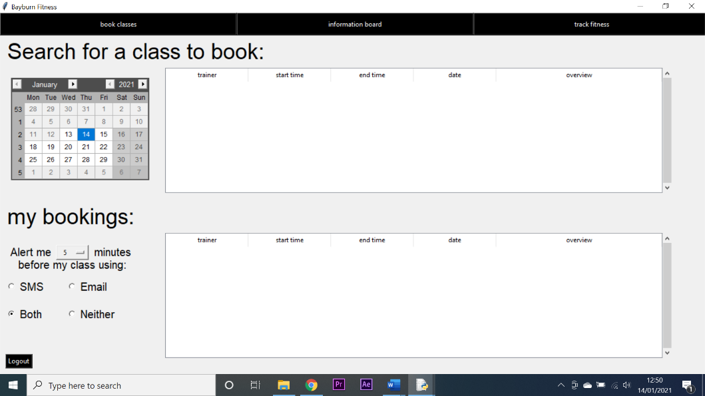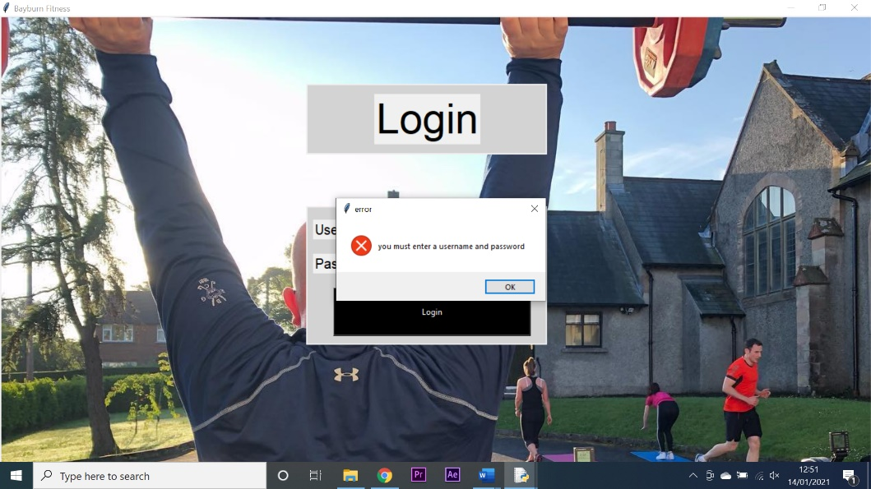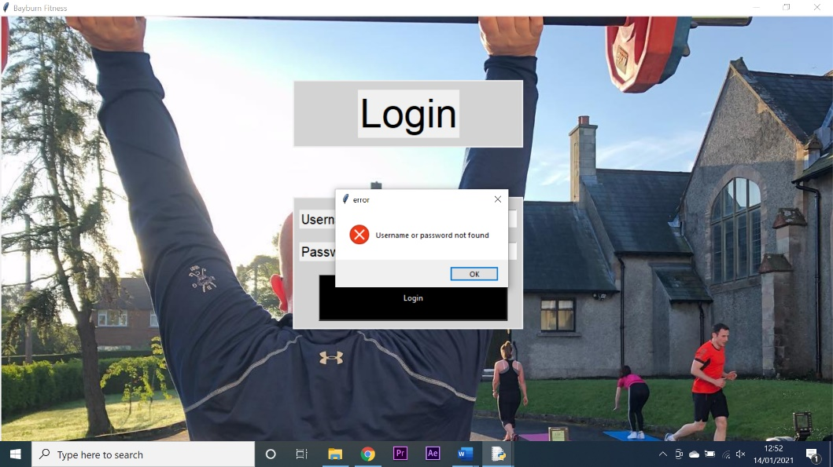

1

3

2

**Testing client class booking functionality:**

|  |  |  |  |  |  |  |  |
| --- | --- | --- | --- | --- | --- | --- | --- |
| Test number | System requirement | Test data type | Test data | Expected outcome | Observed outcome | Match | Comments |
| 1 | create a system that allows clients to book into classes that have been created by trainers. | Valid | I selected a date on the calendar | The top treeview would populate with available classes | The top treeview populated with available classes | Yes | N/A |
| 2 | create a system that allows clients to book into classes that have been created by trainers. | Valid | A class was selected from the top treeview to be booked | The class would appear in the bottom treeview as a client’s booked class | The class appeared in the bottom treeview as a client’s booked class | Yes | N/A |
| 3 | create a system that allows clients to book into classes that have been created by trainers. | Invalid | A class was selected to be booked twice | The duplicate class would be instantly deleted | The duplicate class was instantly deleted | Yes | N/A |
| 4 | create a system that allows clients to book into classes that have been created by trainers. | Valid | A booked class was selected from the bottom treeview to be un-booked | The booking would be deleted | The booking was deleted | Yes | N/A |
| 5 | create a system that allows clients to book into classes that have been created by trainers. | Valid | The system date was changed to be after a booking had taken place | The booking would be automatically deleted | The booking was not automatically deleted | No | There was a problem with the date formatting, once rectified the test was repeated and was successful |
| 6 | create a system that allows clients to be notified of events via emails and text messages. | Valid | The alert system was set for 5 mins before a class and set for both SMS and email, the time was then changed to 30 mins before a booked class | An SMS and email alert would be sent to the client who booked the class | An SMS and email alert was sent to the client who booked the class | Yes | N/A |

**Test screenshots:**

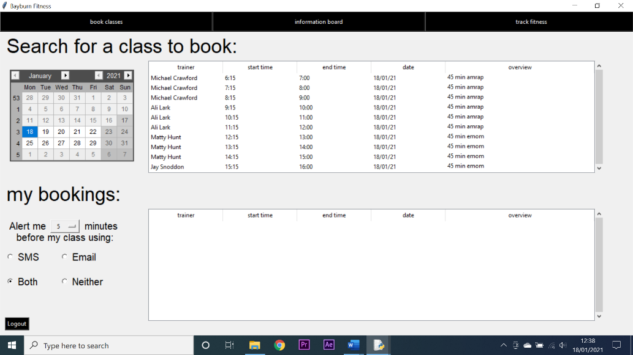

2

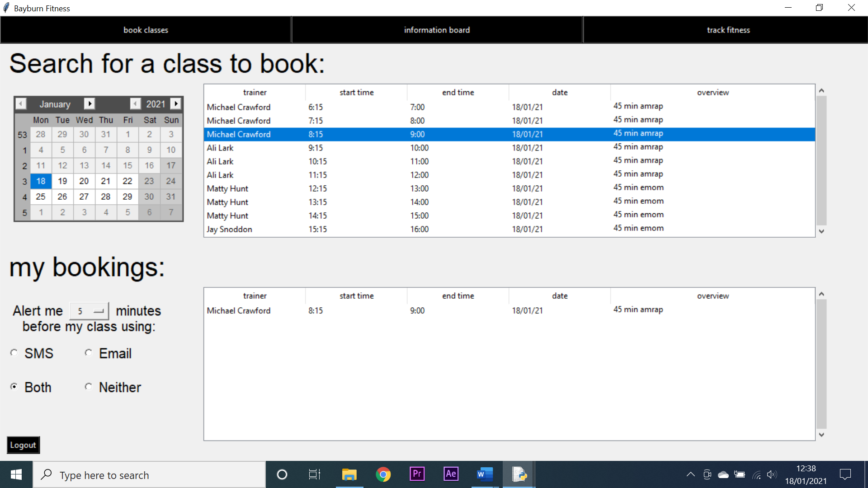

1

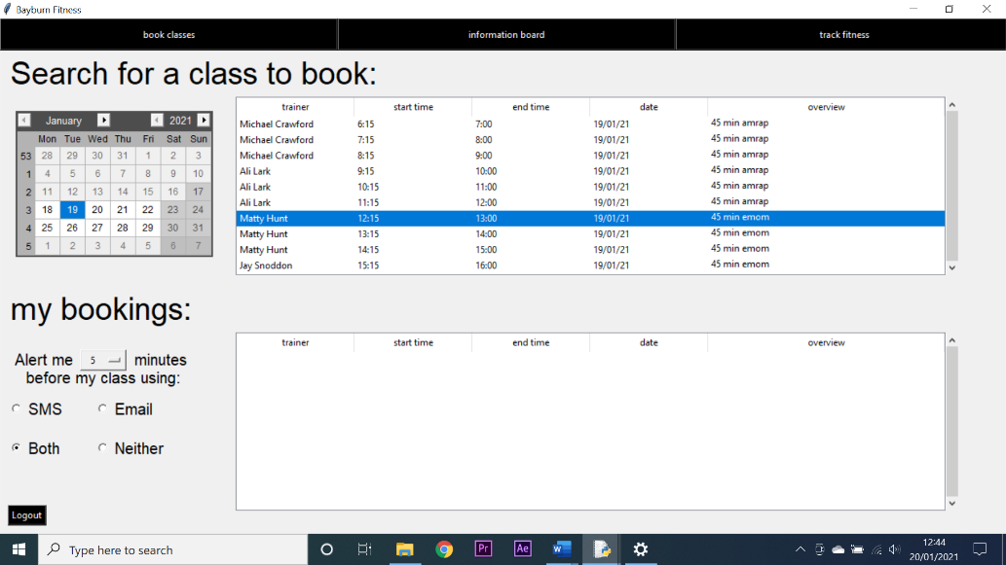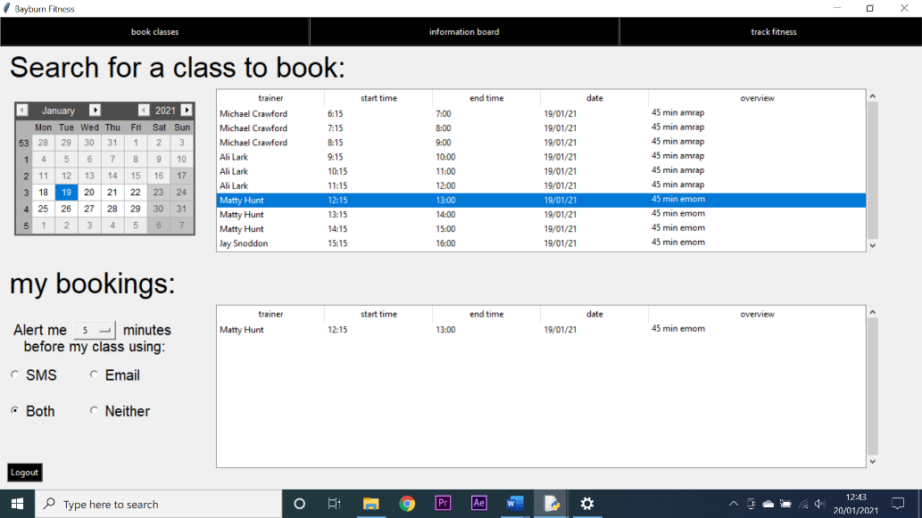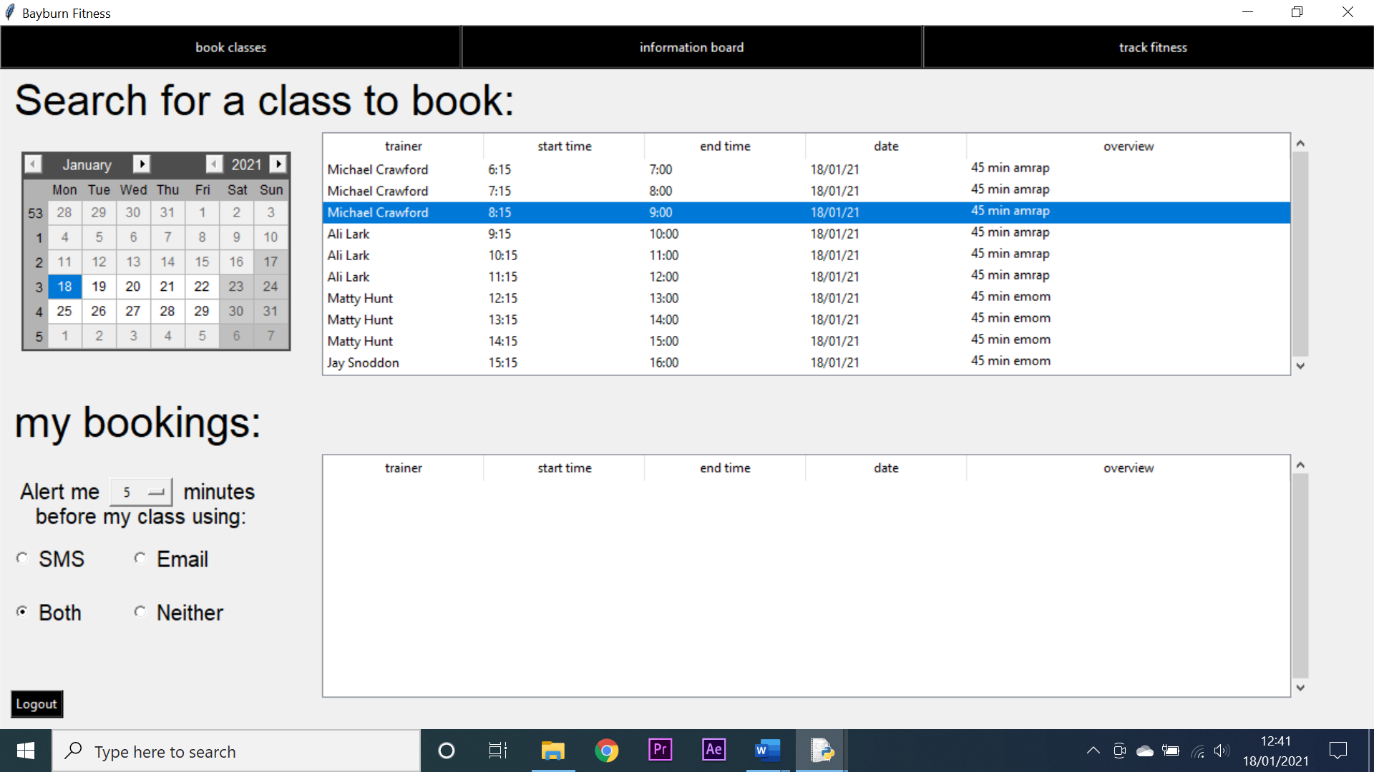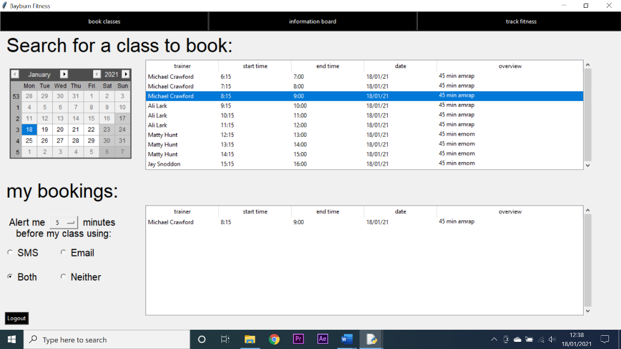

5 - successful

5 - failed

4

3

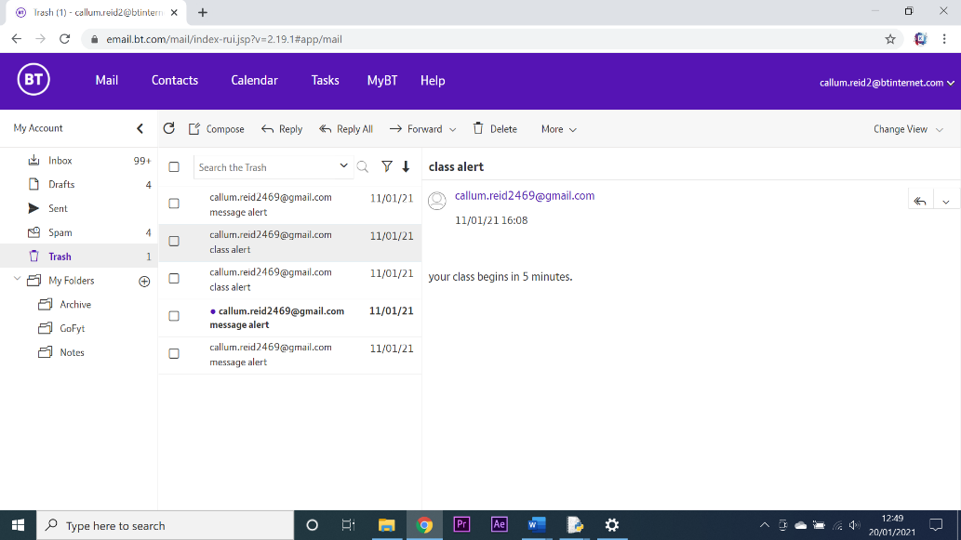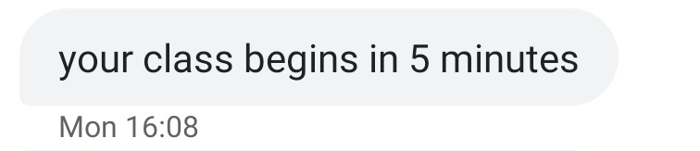

6

6

**Testing client message board functionality:**

|  |  |  |  |  |  |  |  |
| --- | --- | --- | --- | --- | --- | --- | --- |
| Test number | System requirement | Test data type | Test data | Expected outcome | Observed outcome | Match | Comments |
| 1 | create a system that allows for easy remote communication between stakeholders | Valid | A message was selected to be viewed | A message box would open containing the message | A message box opened containing the message | Yes | N/A |
| 2 | create a system that improves the overall experience of being a part of Bayburn Fitness | Valid | The show map button was pressed | An online map would appear showing all locations | An online map did not appear showing all locations | No | This was an issue with implementation of the map generating library and once rectified the test was repeated and successful |
| 3 | create a system that allows clients to easily communicate with managers and trainers | Valid | The alert system was set to email, and a message was sent | An email would be sent to the client | An email was sent to the client | Yes | N/A |

**Test screenshots:**

2 - failed

1

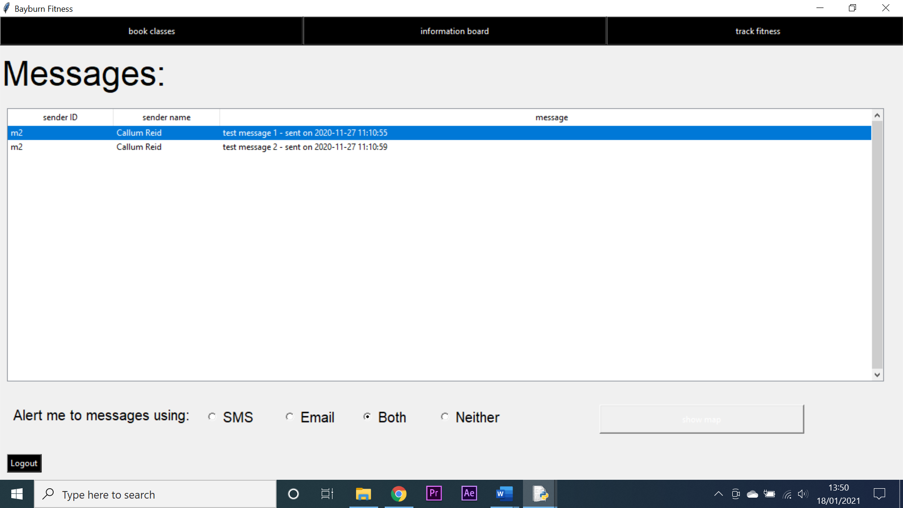 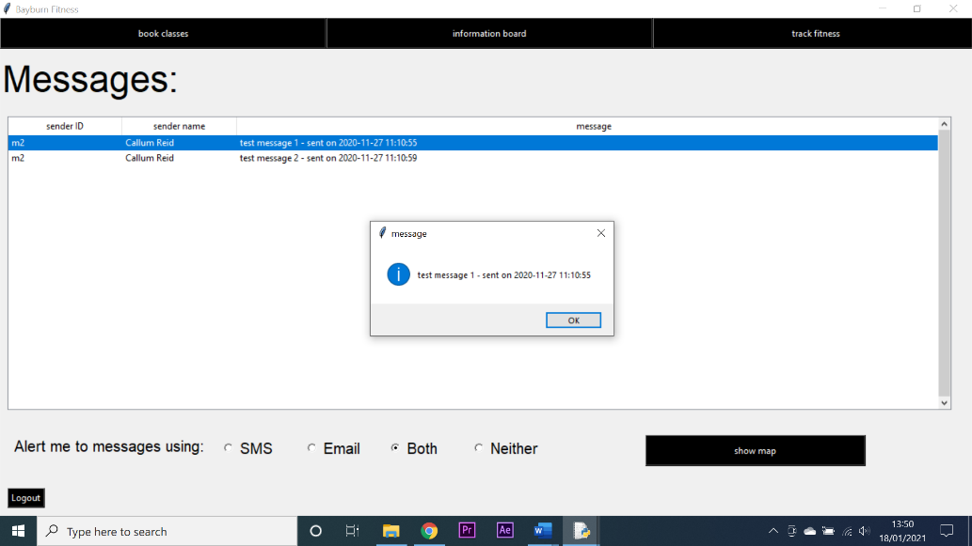

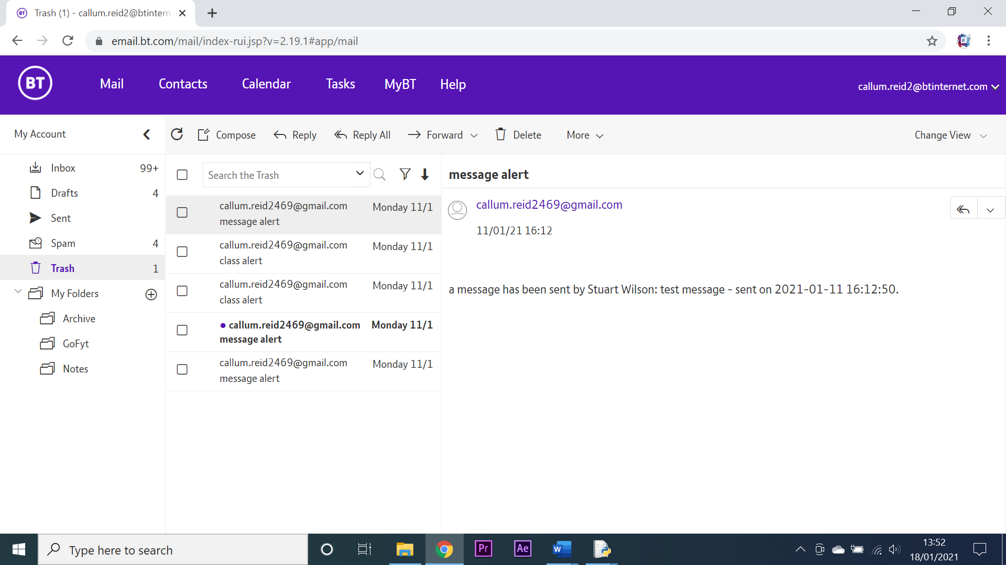 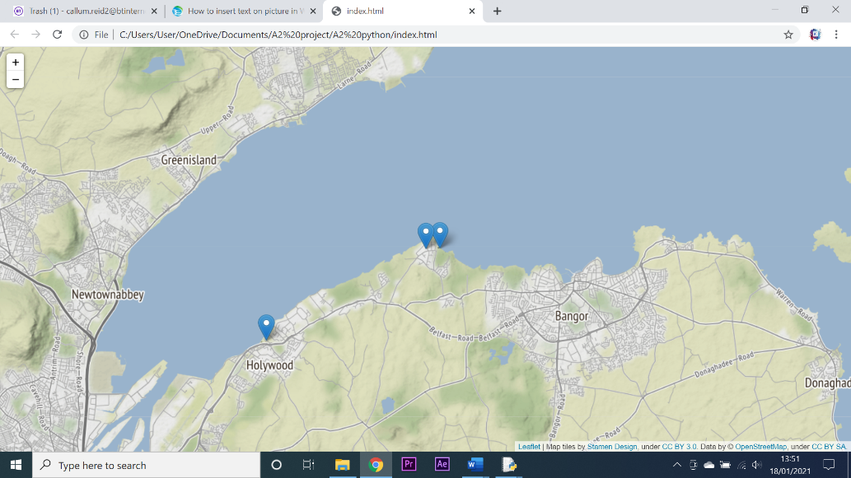

2 - successful

3

**Testing client fitness tracker functionality:**

|  |  |  |  |  |  |  |  |
| --- | --- | --- | --- | --- | --- | --- | --- |
| Test number | System requirement | Test data type | Test data | Expected outcome | Observed outcome | Match | Comments |
| 1 | create a system that allows clients to set targets for their fitness and for these targets to be visualised on the fitness tracker. | Valid | An exercise name was entered and the create exercise button was pressed | The exercise would be added to the treeview | The exercise was added to the treeview | Yes | N/A |
| 2 | create a system that keeps human error to a minimum by validating inputs. | Null | No data was entered and the create exercise button was pressed | An error message would be generated | An error message was generated | Yes | N/A |
| 3 | create a system that allows clients to set targets for their fitness and for these targets to be visualised on the fitness tracker. | Invalid | The Same exercise name was entered twice | An error message would be generated | An error message was generated | Yes | N/A |
| 4 | create a system that allows clients to set targets for their fitness and for these targets to be visualised on the fitness tracker. | Invalid | No exercise was selected and the delete exercise button was pressed | An error message would be generated | An error message was generated | Yes | N/A |
| 5 | create a system that allows clients to set targets for their fitness and for these targets to be visualised on the fitness tracker. | Valid | An exercise was selected and the delete button was pressed | The exercise would be deleted | The exercise was deleted | Yes | N/A |
| 6 | create a system that allows clients to set targets for their fitness and for these targets to be visualised on the fitness tracker. | Valid | Data was inputted into the recording boxes and an exercise was selected then the record performance button was pressed | The performance would be recorded | The performance was recorded | Yes | N/A |
| 7 | create a system that keeps human error to a minimum by validating inputs. | Invalid/null | Invalid/null data was inputted into the recording boxes when an exercise was selected, and the record performance button was pressed | An error message would be generated | An error message was generated | Yes | N/A |
| 8 | create a system that allows clients to set targets for their fitness and for these targets to be visualised on the fitness tracker. | Valid | An exercise was selected, and the show graph button was pressed | A graph of that exercise would be generated | A graph of that exercise was generated | Yes | N/A |
| 9 | create a system that allows clients to set targets for their fitness and for these targets to be visualised on the fitness tracker. | Valid | An exercise was selected, and the generate report button was pressed | A file dialogue box would open allowing the user to save the report | No dialogue box was opened | No | This problem was caused by the button not being linked to the correct function. Once rectified, the test was repeated and was successful |

**Test screenshots:**

2

1

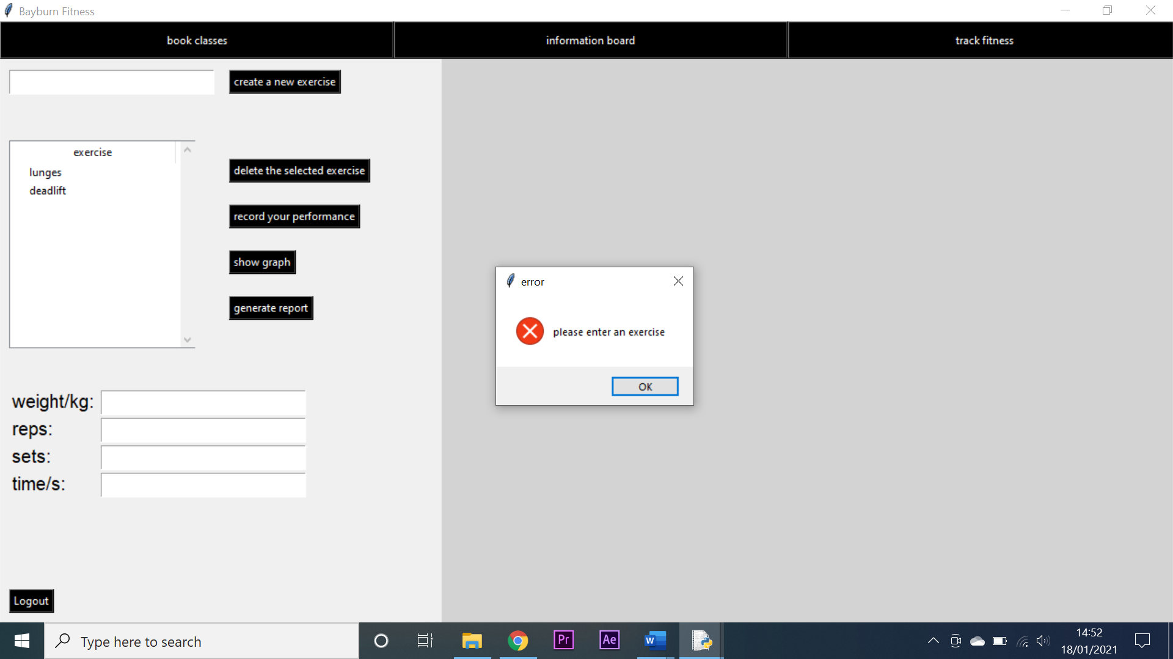 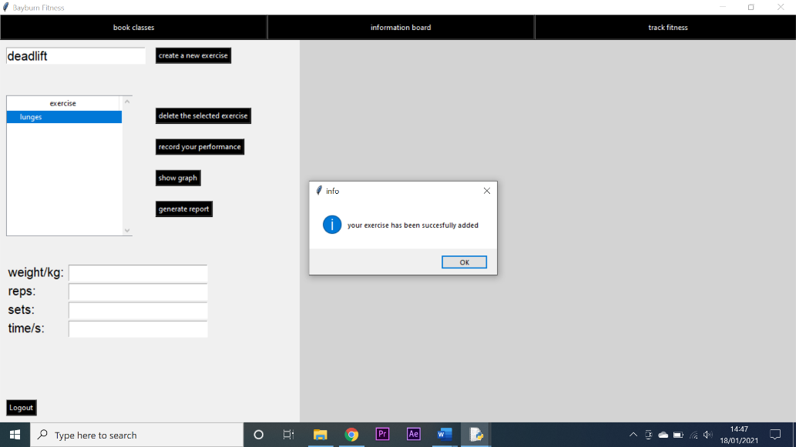

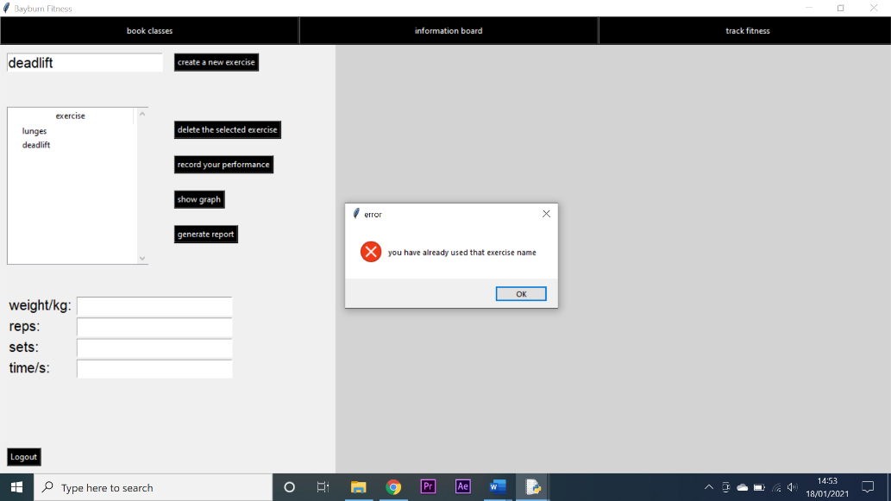 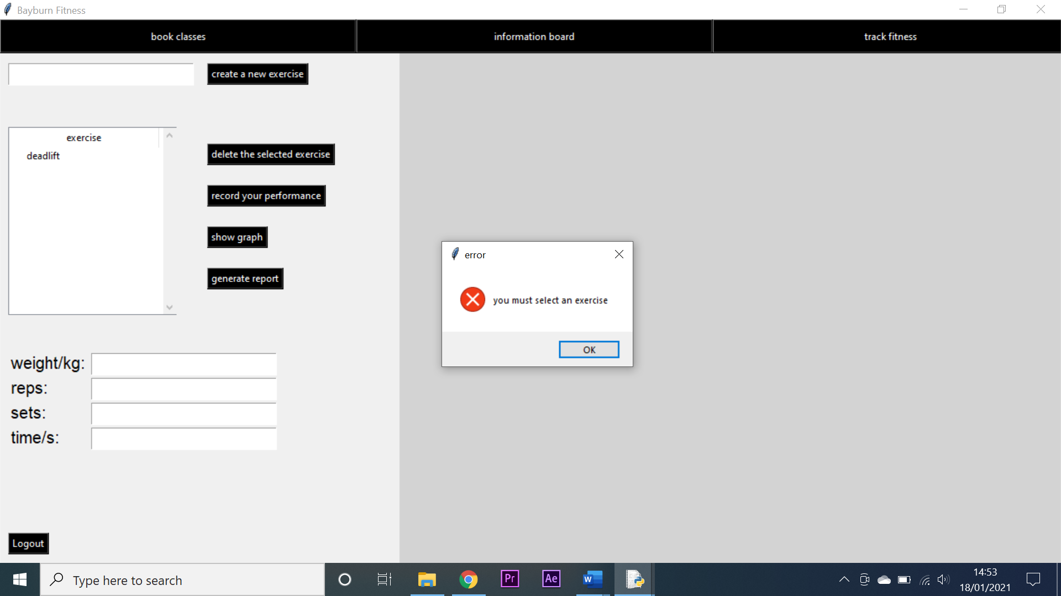

4

3

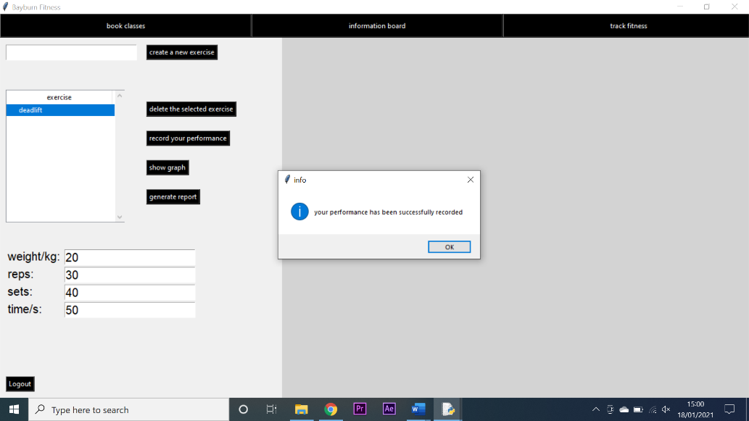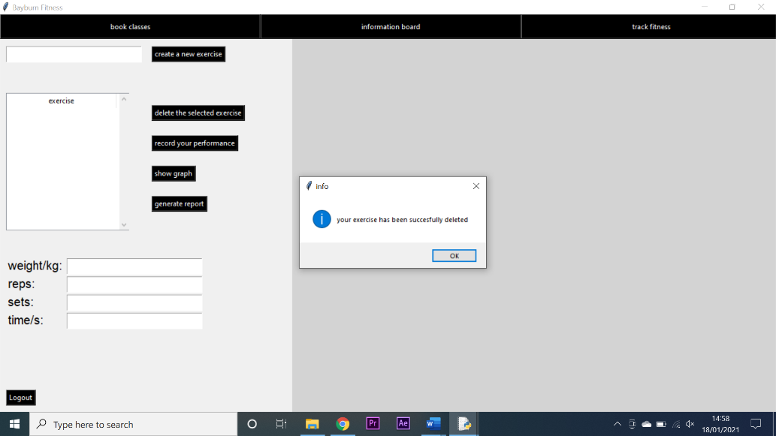

6

5

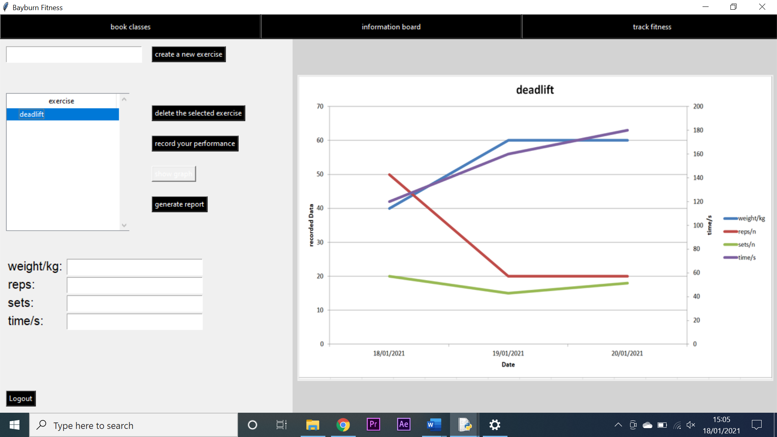 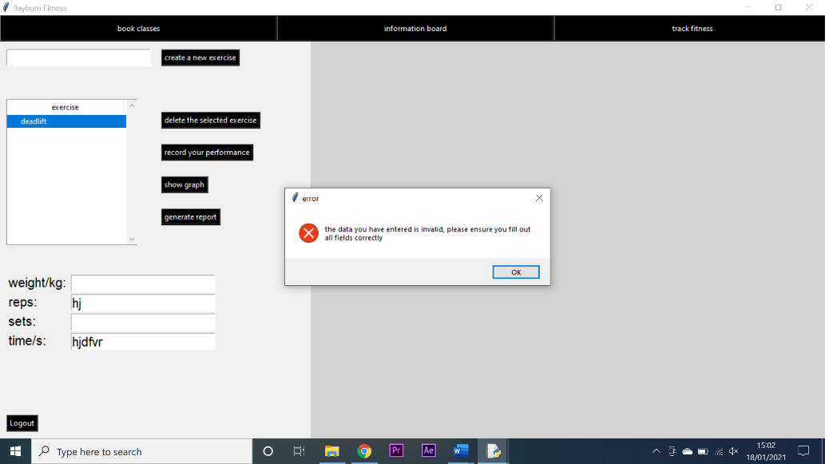

8

7

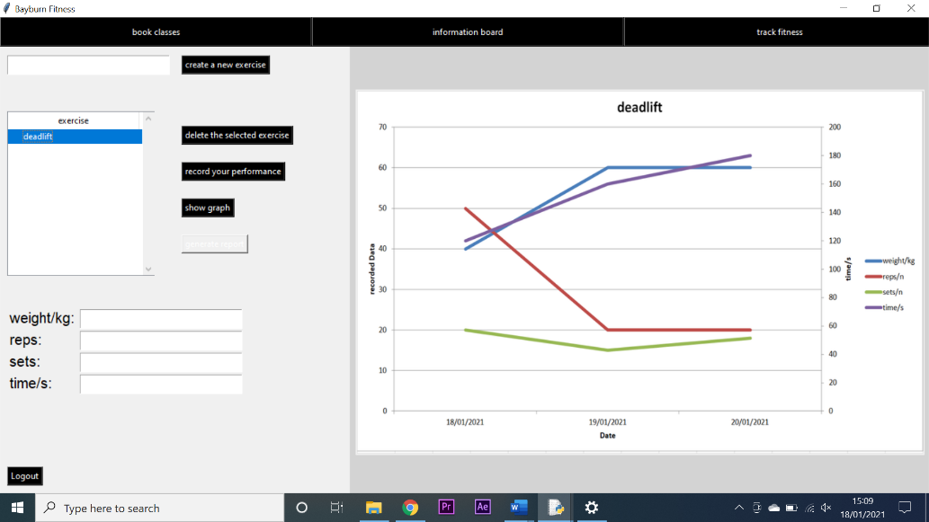 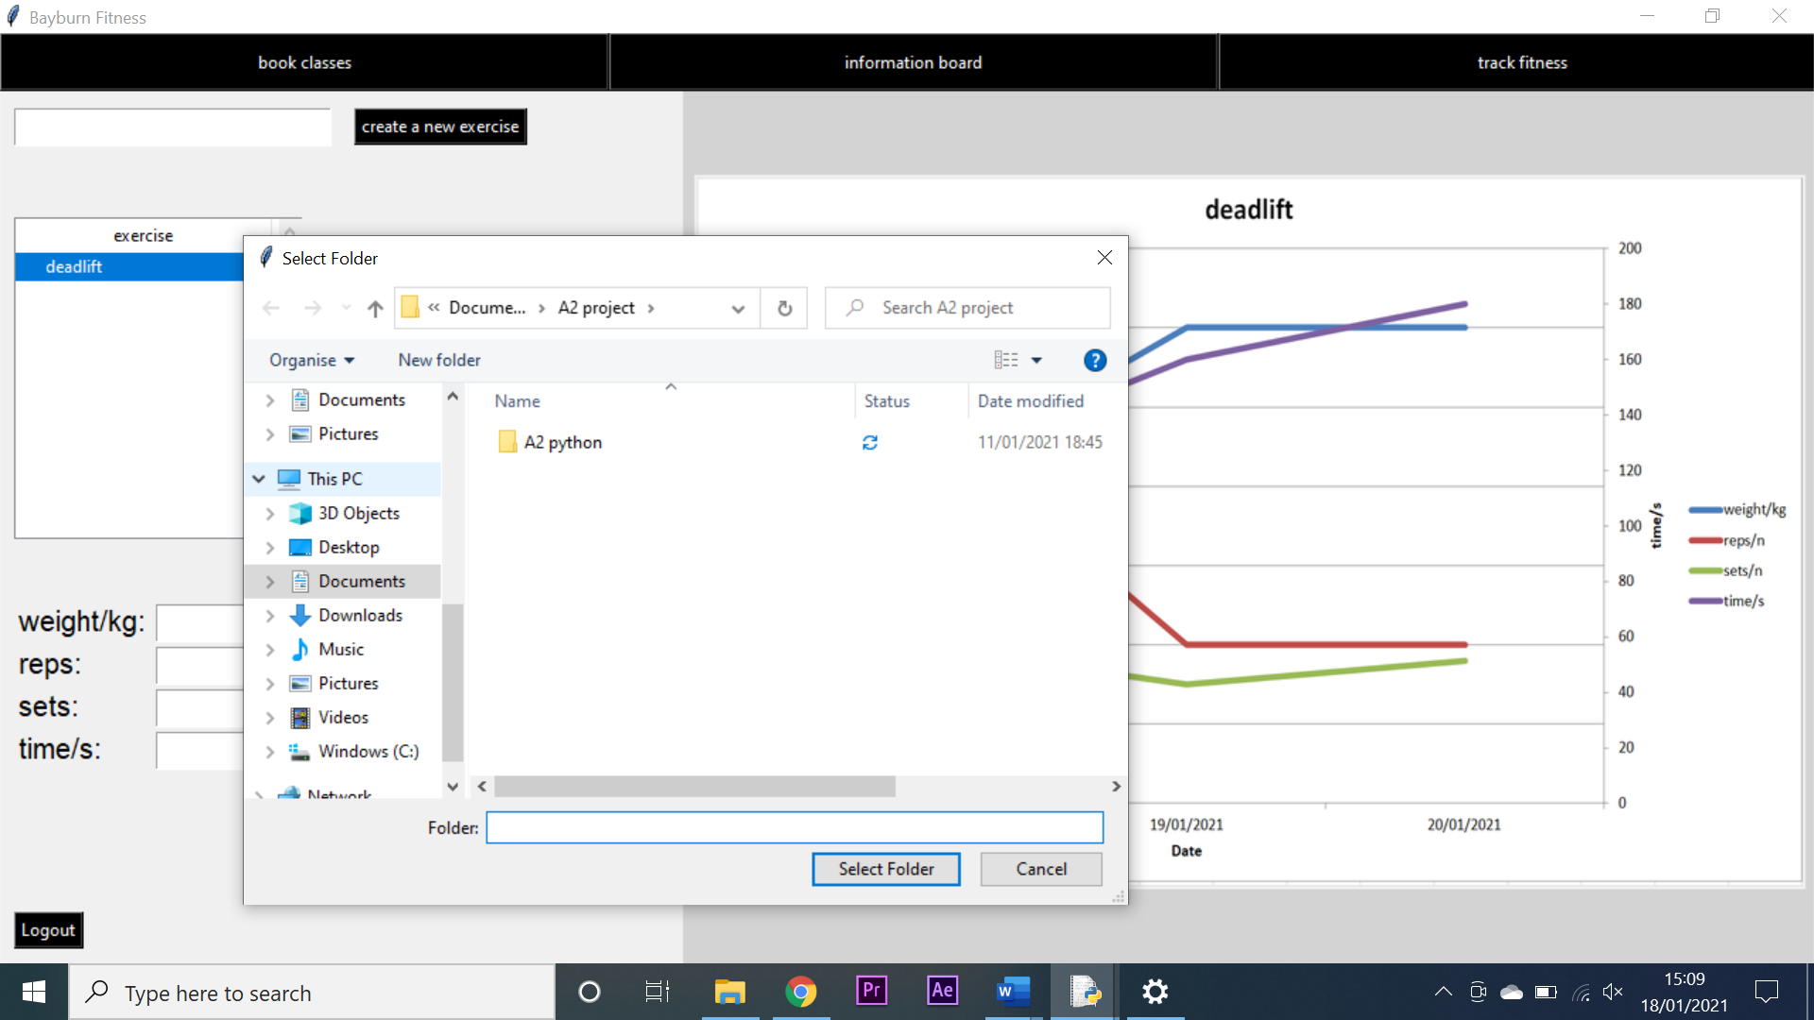

9 - successful

9 - failed

**Testing client screen navigation:**

|  |  |  |  |  |  |  |  |
| --- | --- | --- | --- | --- | --- | --- | --- |
| Test number | System requirement | Test data type | Test data | Expected outcome | Observed outcome | Match | Comments |
| 1 | create an intuitive GUI through which my system can be navigated | Valid | I attempted to navigate to the book classes screen | I would arrive at the book classes screen | I arrived at the book classes screen | Yes | N/A |
| 2 | create an intuitive GUI through which my system can be navigated | Valid | I attempted to navigate to the information board screen | I would arrive at the information board screen | I arrived at the information board screen | Yes | N/A |
| 3 | create an intuitive GUI through which my system can be navigated | Valid | I attempted to navigate to the fitness tracker screen | I would arrive at the fitness tracker screen | I arrived at the fitness tracker screen | Yes | N/A |
| 4 | create an intuitive GUI through which my system can be navigated | Valid | I attempted to logout | I would arrive at the login screen | I arrived at the login screen | Yes | N/A |

**Test screenshots:**

2

1

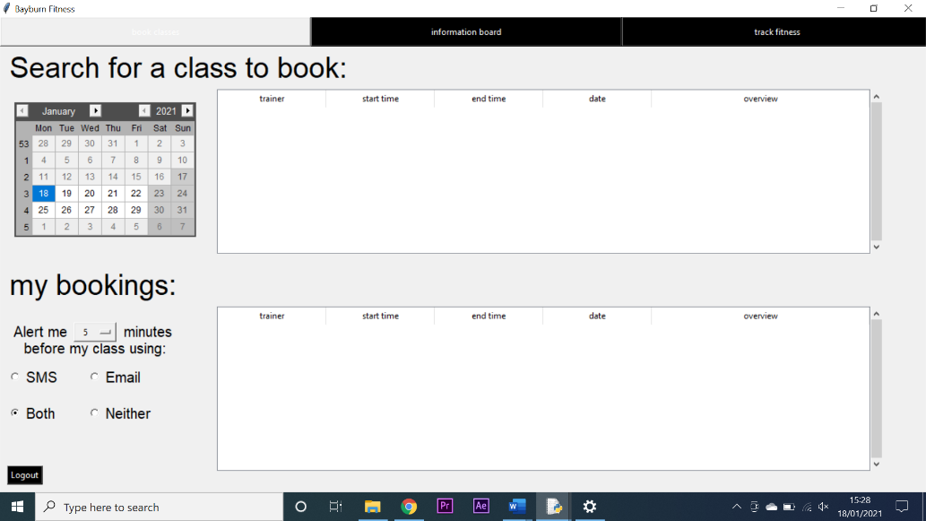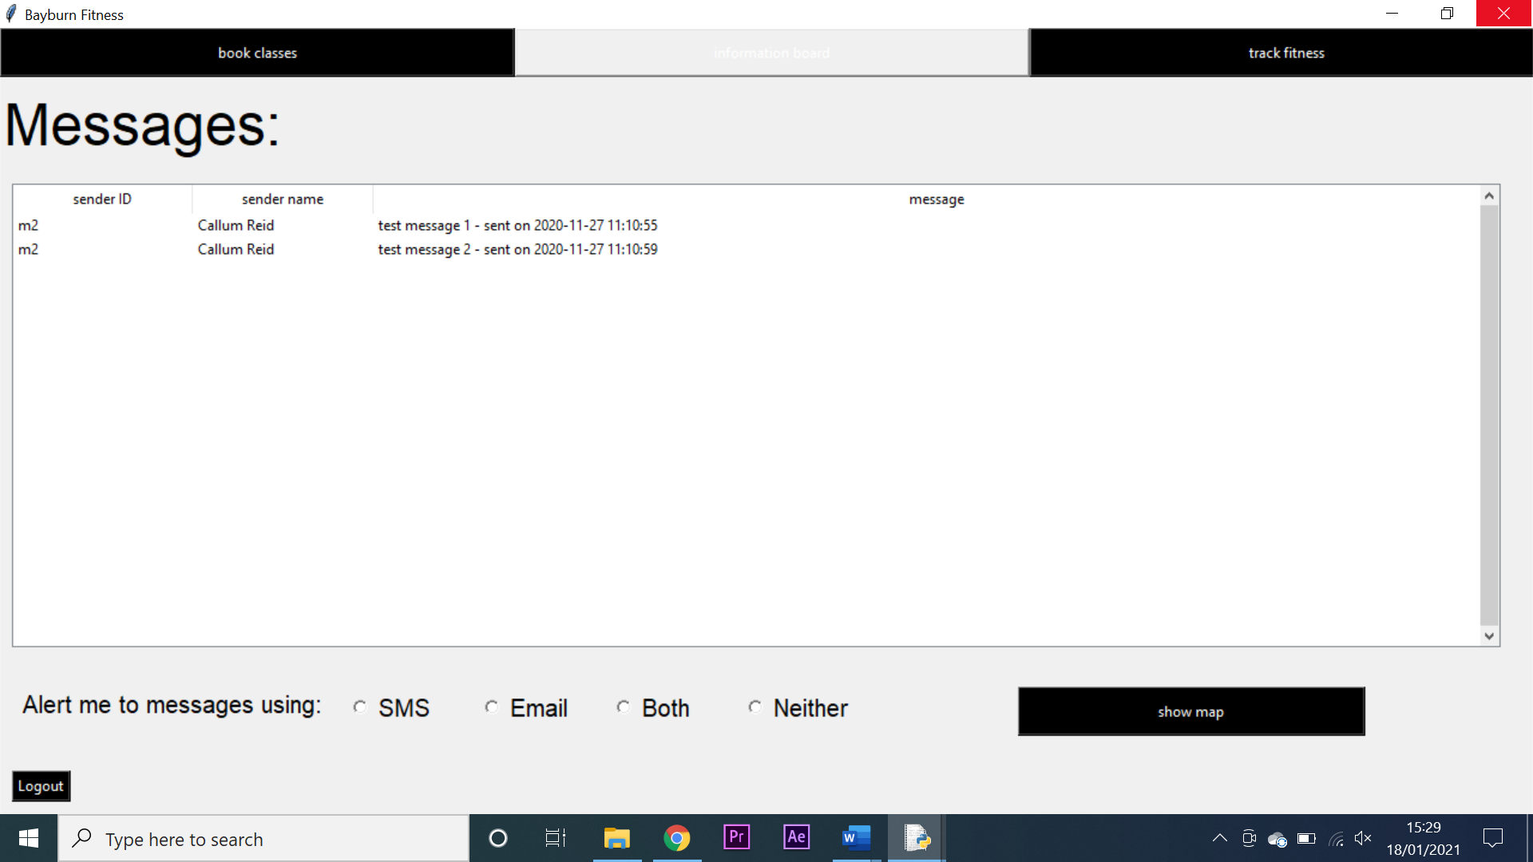

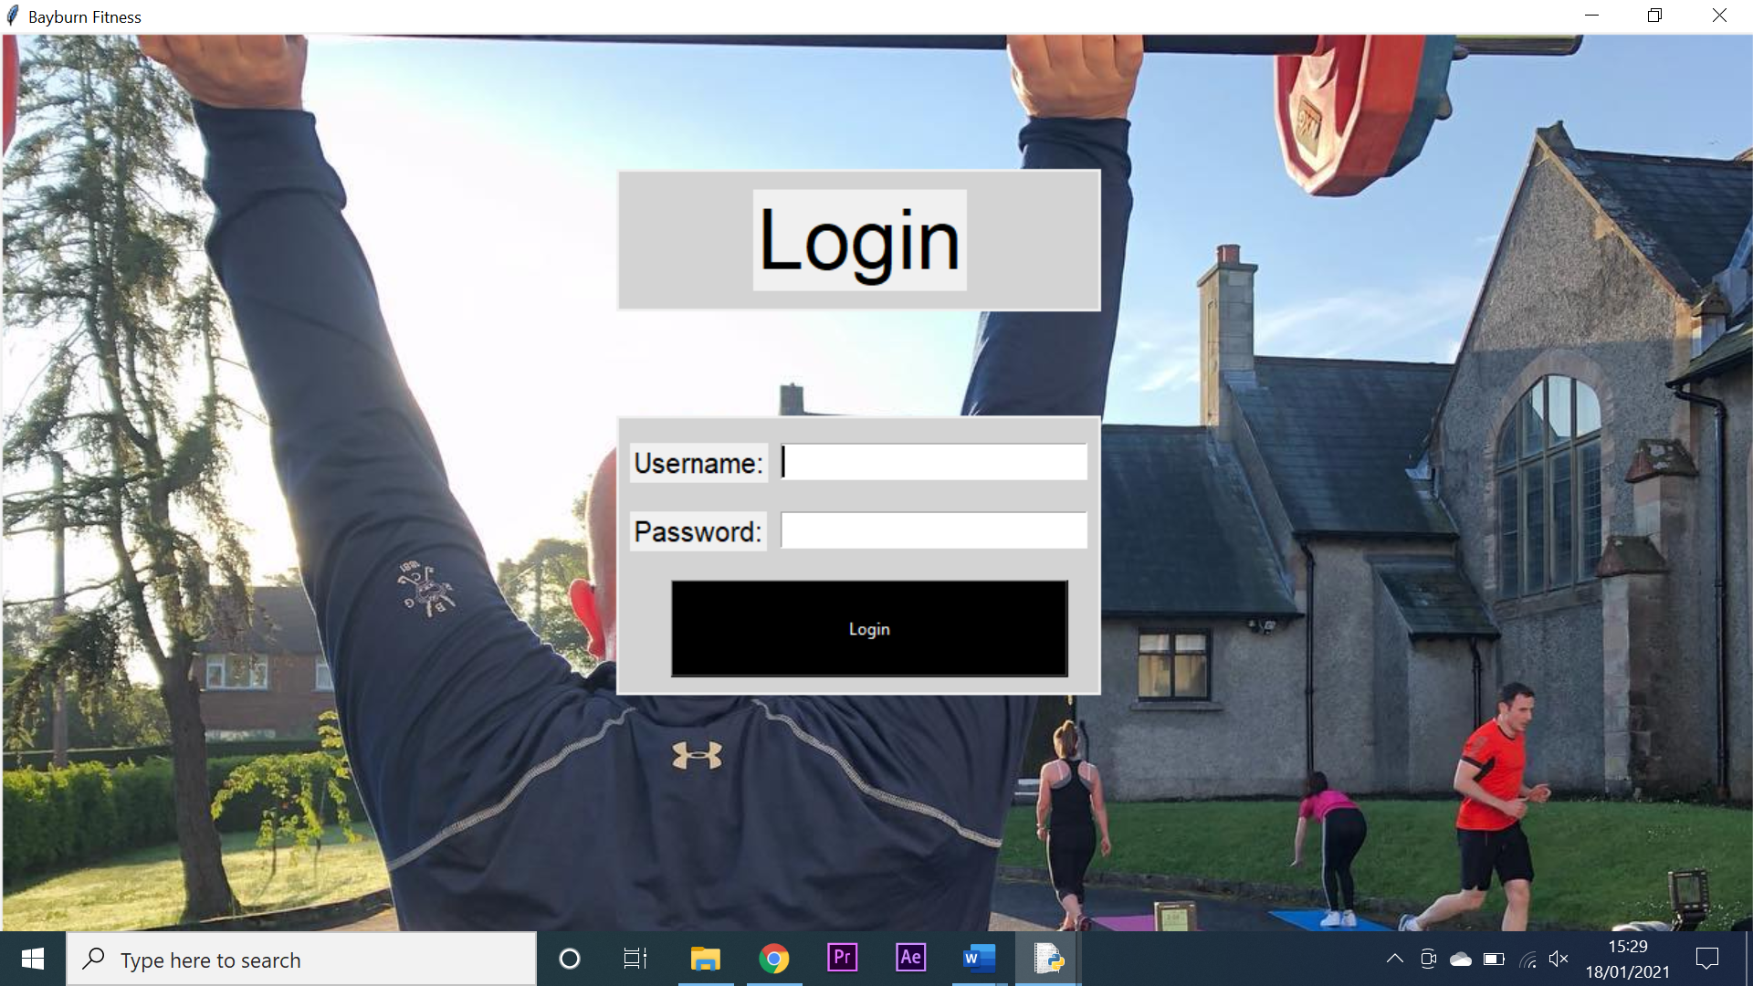 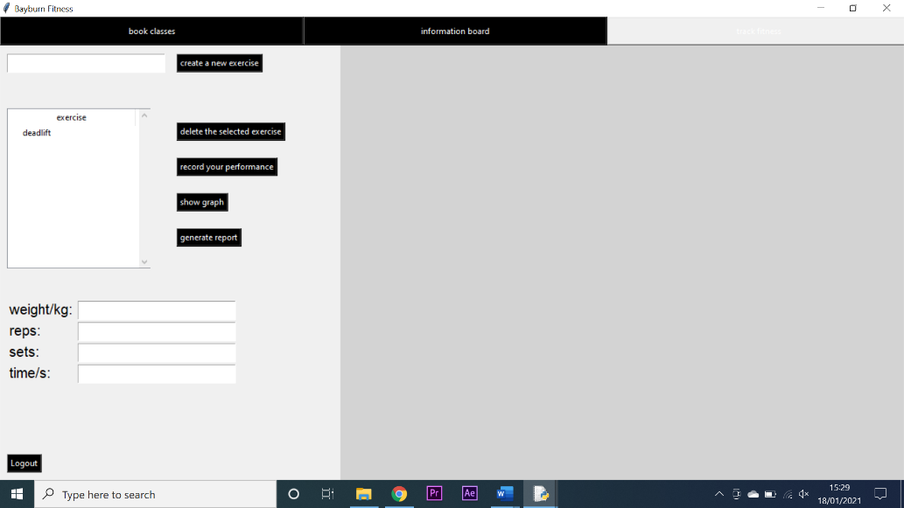

4

3

**Testing trainer class making functionality:**

|  |  |  |  |  |  |  |  |
| --- | --- | --- | --- | --- | --- | --- | --- |
| Test number | System requirement | Test data type | Test data | Expected outcome | Observed outcome | Match | Comments |
| 1 | create a system that allows trainers to create, edit and delete classes with ease | Valid | Data was inputted into the interface and the create class button was pressed | A class would be created and updated in the treeview | A class was created and updated in the treeview | Yes | N/A |
| 2 | create a system that keeps human error to a minimum by validating inputs. | Invalid/null | Invalid/null data was inputted into the interface and the create class button was pressed | An error message would be generated | An error message was not generated | Not | The code responsible for the error message was not implemented correctly and once rectified the test was repeated and was successful |
| 3 | create a system that allows trainers to create, edit and delete classes with ease | Valid | A class was selected from the treeview to be deleted | A question box would appear allowing the class to be deleted | A question box appeared allowing the class to be deleted | Yes | N/A |

**Test screenshots:**

2 - failed

1

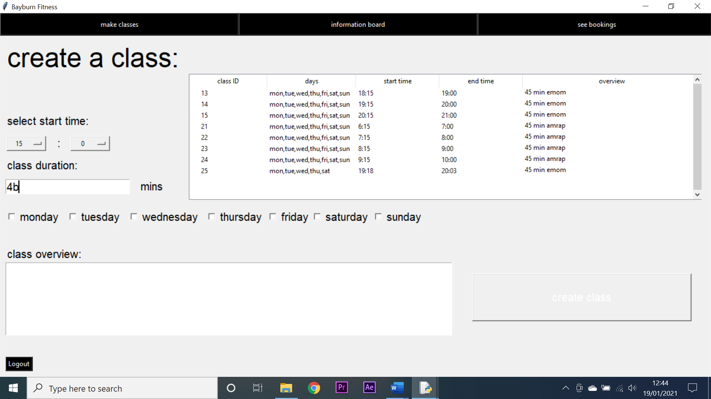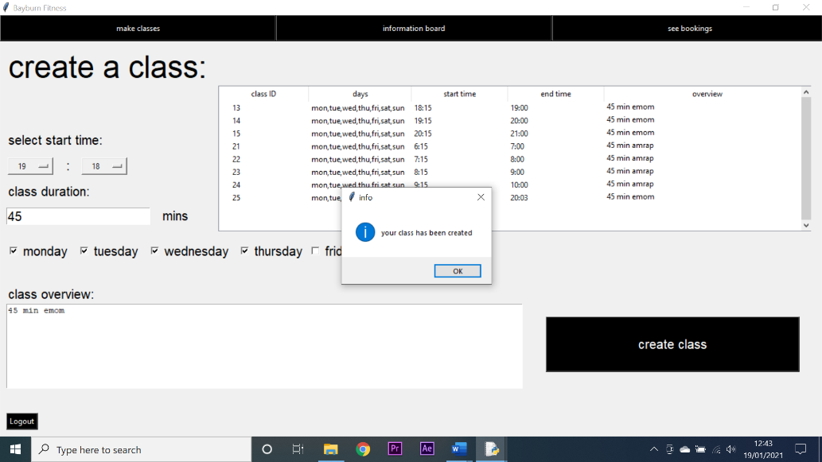

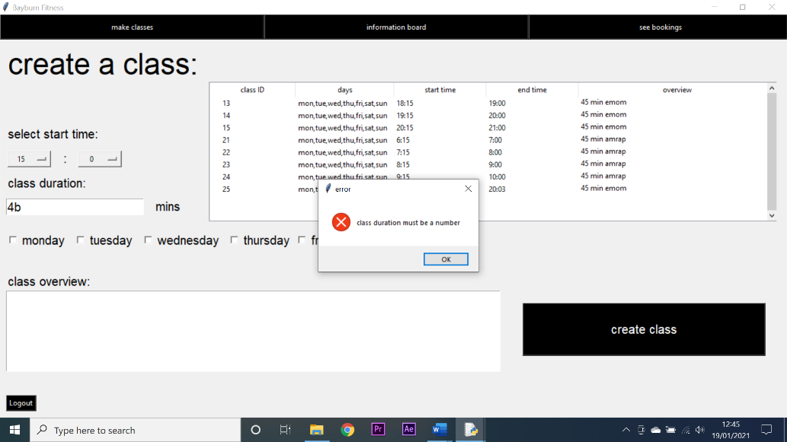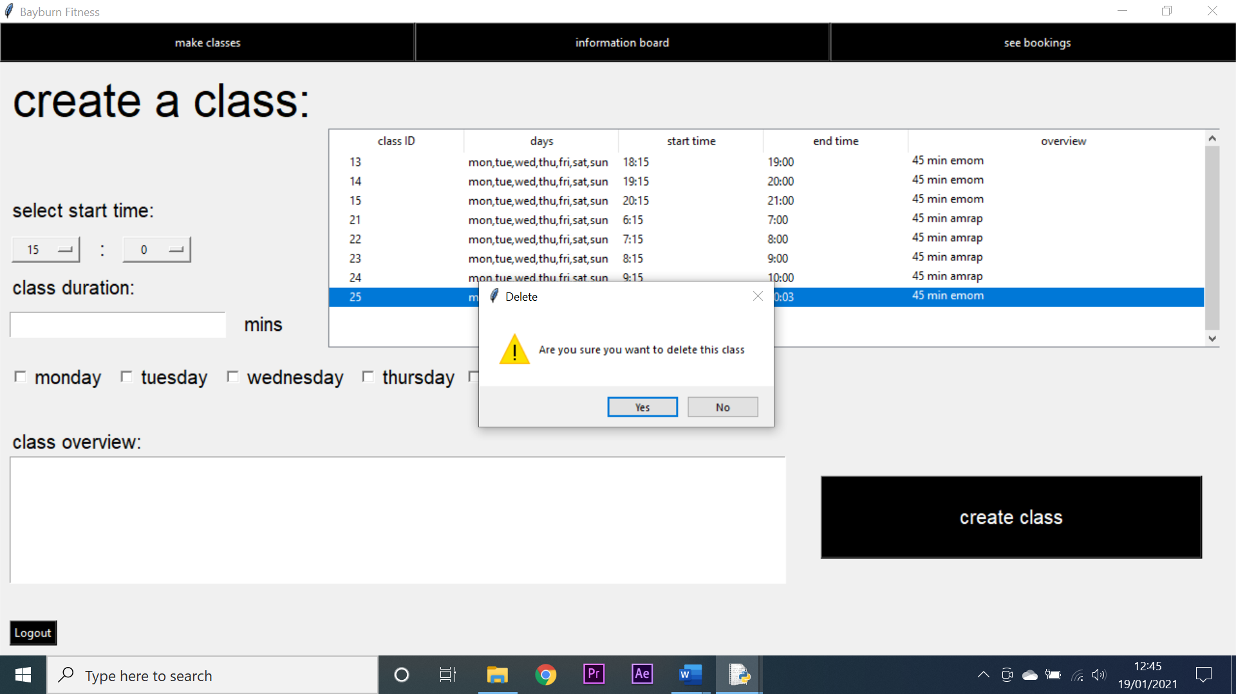

3

2 - successful

**Testing trainer information board functionality:**

|  |  |  |  |  |  |  |  |
| --- | --- | --- | --- | --- | --- | --- | --- |
| Test number | System requirement | Test data type | Test data | Expected outcome | Observed outcome | Match | Comments |
| 1 | create a system that allows trainers to communicate easily and remotely with clients and managers | Valid | A test message was entered and then sent | The message would appear on the board | The message appeared on the board | Yes | N/A |
| 2 | create a system that keeps human error to a minimum by validating inputs. | Null | No data was entered, and the send message button was pressed | An error message would appear | An error message appeared | Yes | N/A |
| 3 | create a system that allows trainers to communicate easily and remotely with clients and managers | Valid | A message was selected by that was not sent by the trainer I was logged in as | The message would be displayed in an info box | The message was displayed in an info box | Yes | N/A |
| 4 | create a system that allows trainers to communicate easily and remotely with clients and managers | Valid | A message sent by the trainer currently logged in was selected to be deleted | A question box would appear allowing the user to delete the message | No message box appeared | No | This was due to an error when comparing user ID’s, once rectified the test was repeated and was successful |

**Test screenshots:**

2

1

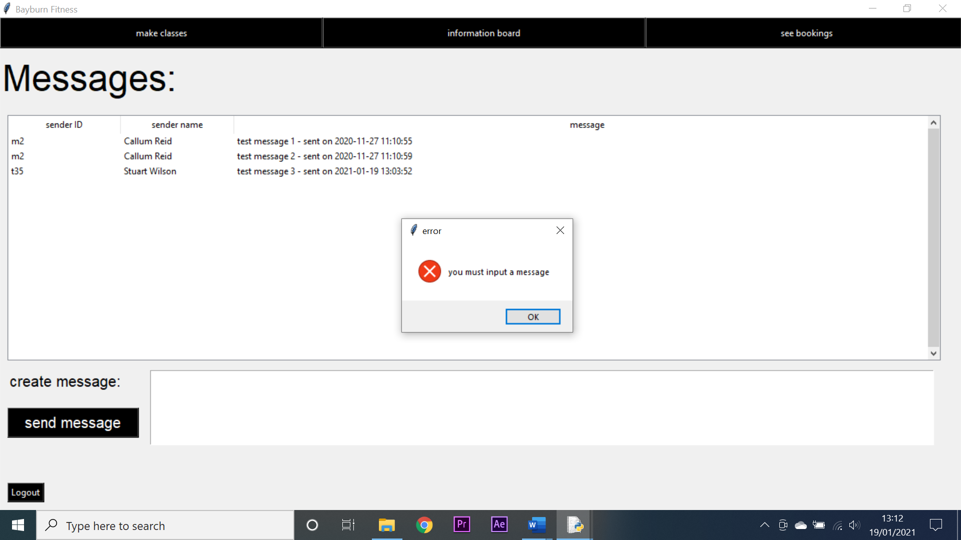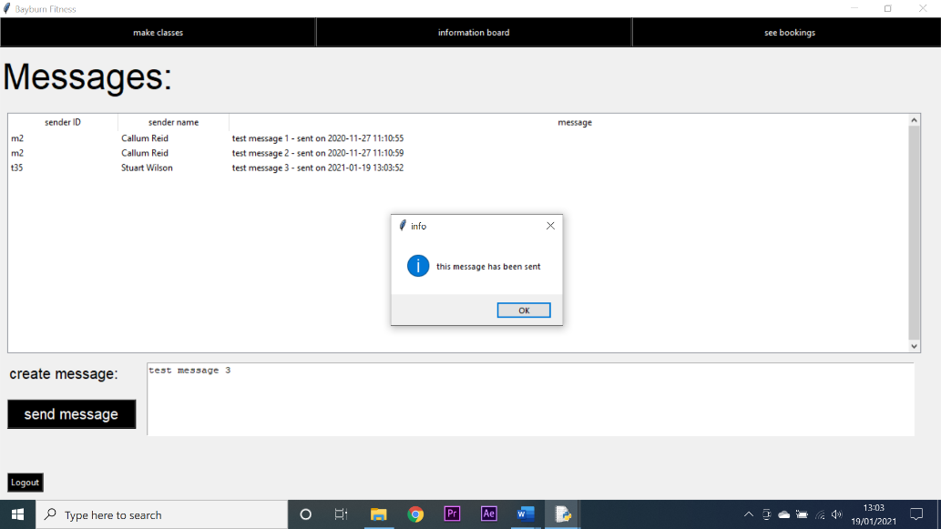

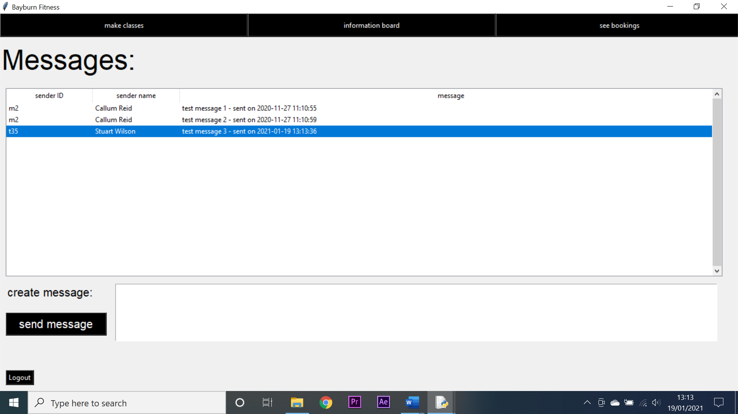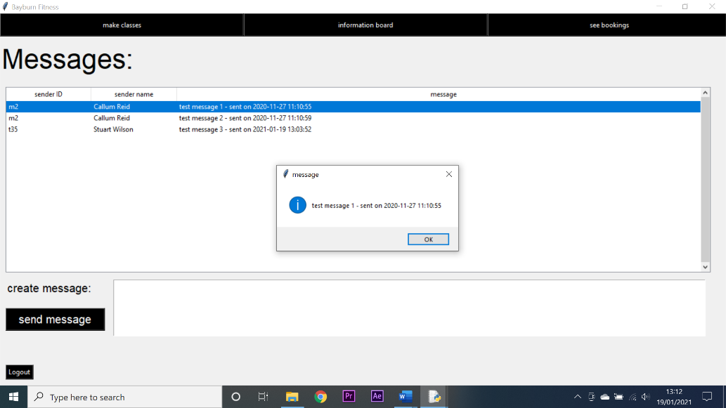

4 - failed

3

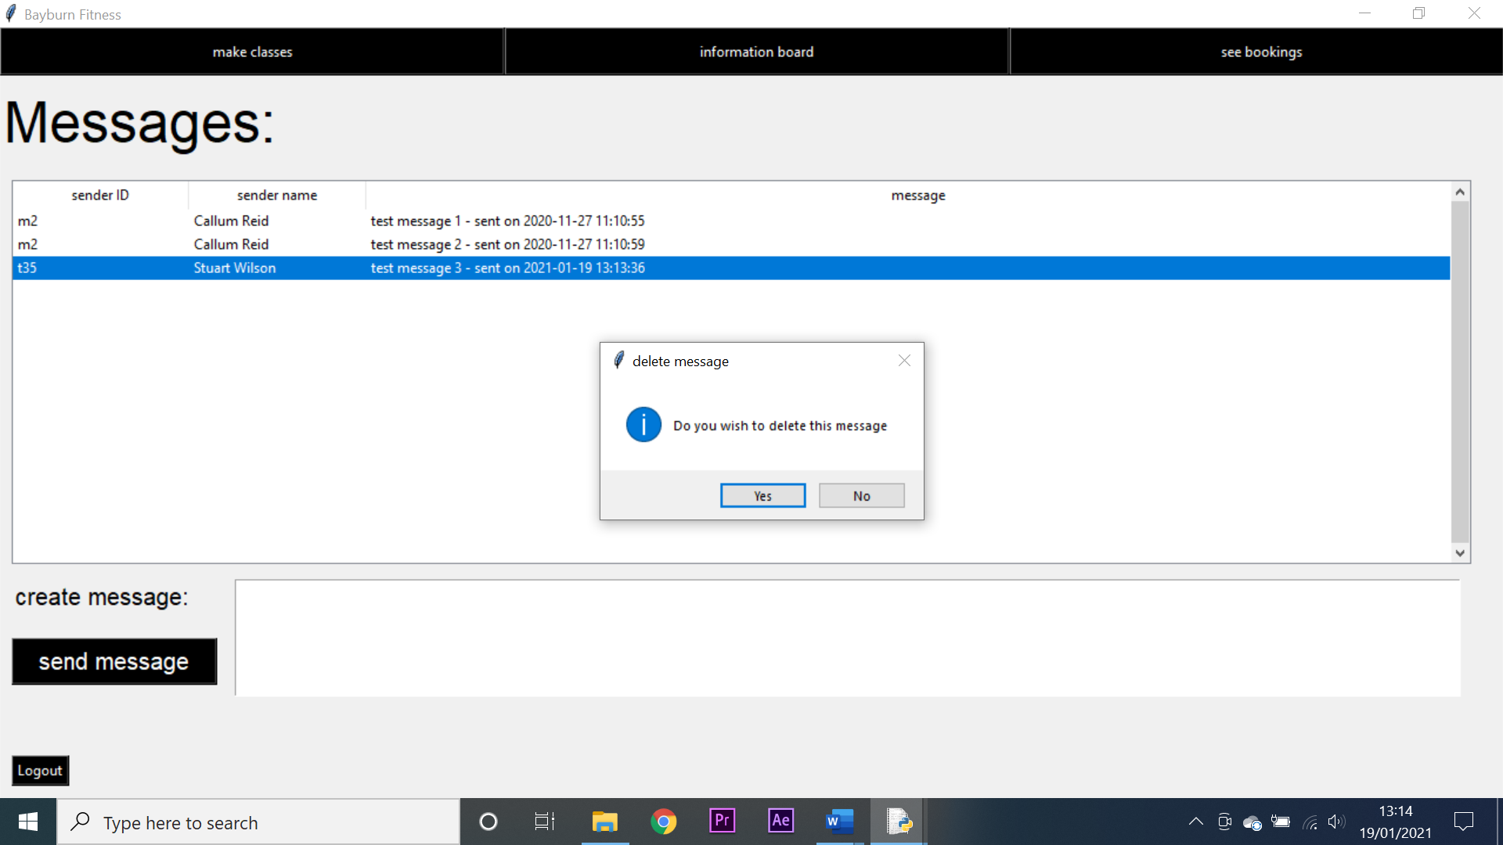

4 - successful

**Testing trainer booking viewer functionality:**

|  |  |  |  |  |  |  |  |
| --- | --- | --- | --- | --- | --- | --- | --- |
| Test number | System requirement | Test data type | Test data | Expected outcome | Observed outcome | Match | Comments |
| 1 | create a system that allows a trainer to view all of the people who have booked into their classes | Valid | none | The top treeview will automatically populate with the next 30 days of classes for that trainer | The top treeview automatically populated with the next 30 days of classes for that trainer | Yes | N/A |
| 2 | create a system that allows a trainer to view all of the people who have booked into their classes | Valid | A class was selected to view all bookings into that class | The bottom treeview would populate with people who had booked into that class | The bottom treeview populated with people who had booked into that class | Yes | N/A |
| 3 | create a system that allows a trainer to view all of the people who have booked into their classes | Valid | A person was selected on a class of the current date to be recorded as present | A question box would appear allowing the trainer to mark them as present | A question box appeared allowing the trainer to mark them as present | Yes | N/A |
| 4 | create a system that allows a trainer to view all of the people who have booked into their classes | Invalid | A person was selected on a class not on the current date to be recorded as present | An error message would appear | No error message appeared | No | There was an error in how dates were recorded in the database, once rectified the test was repeated and successful |

**Test screenshots:**

2

1

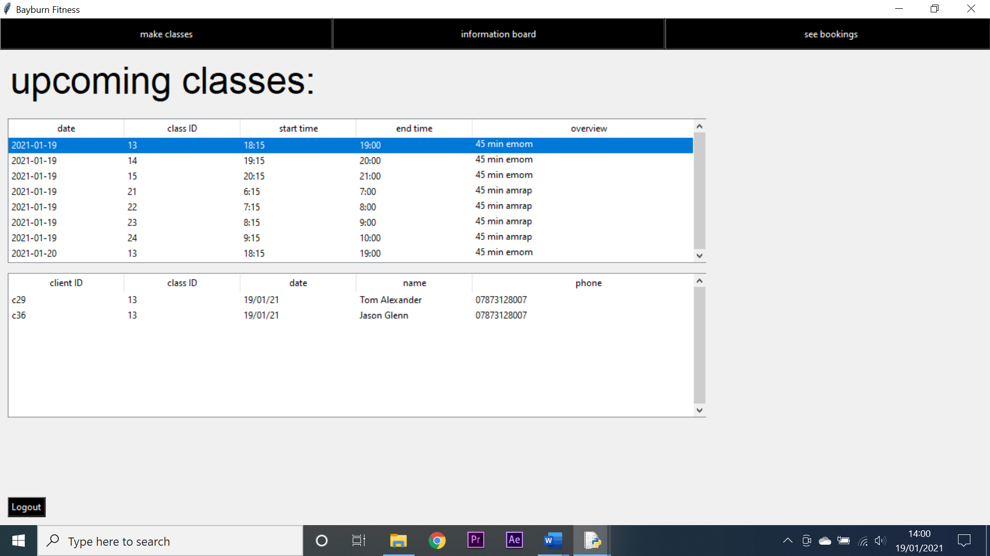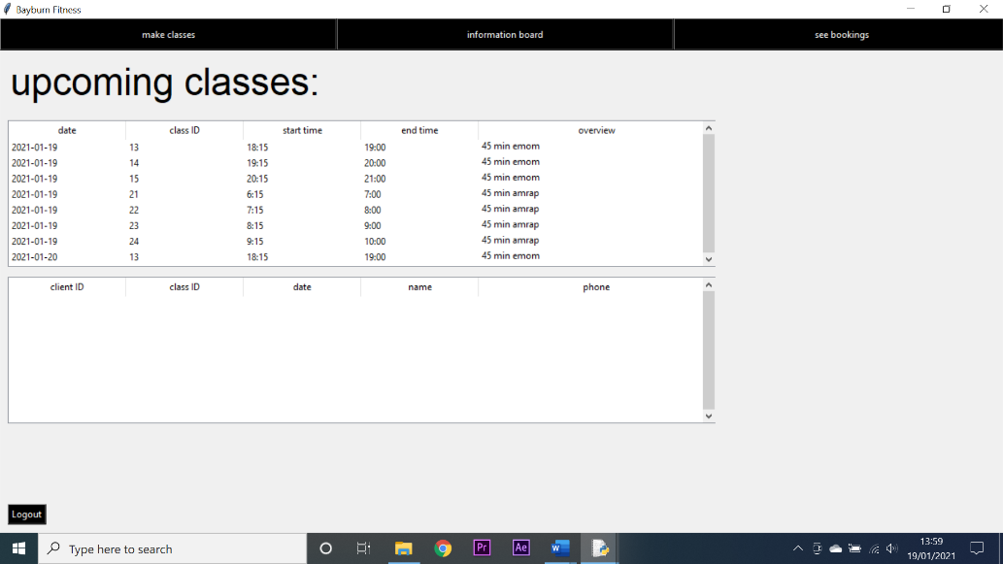

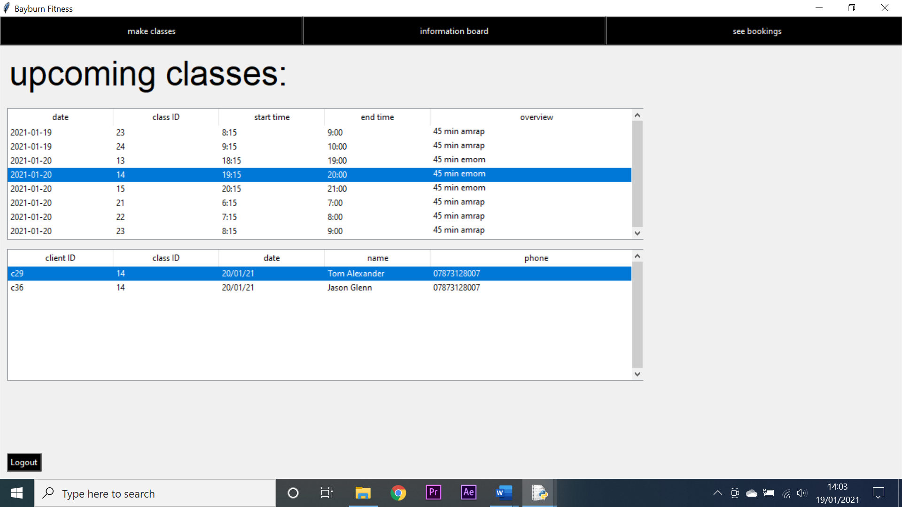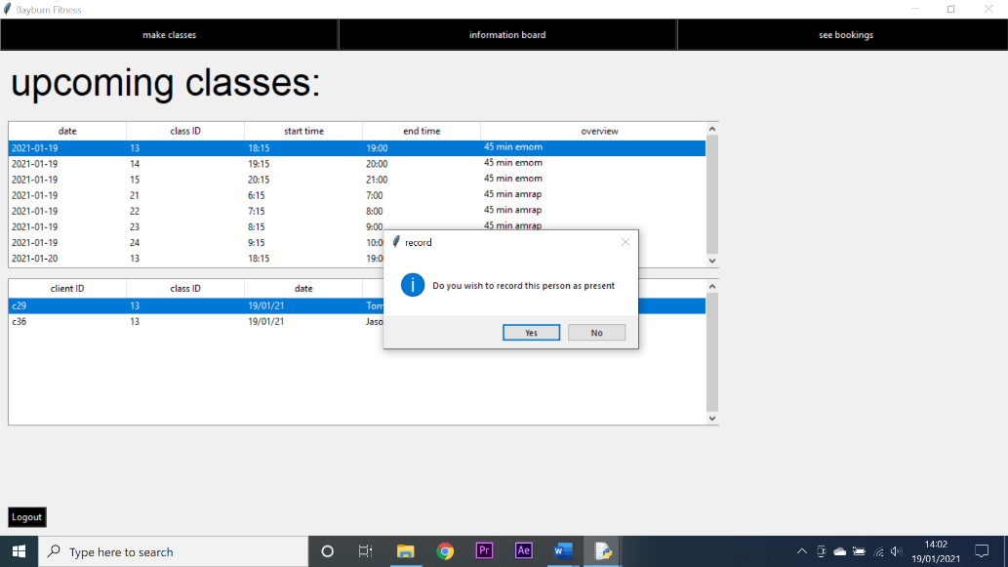

4 - failed

3

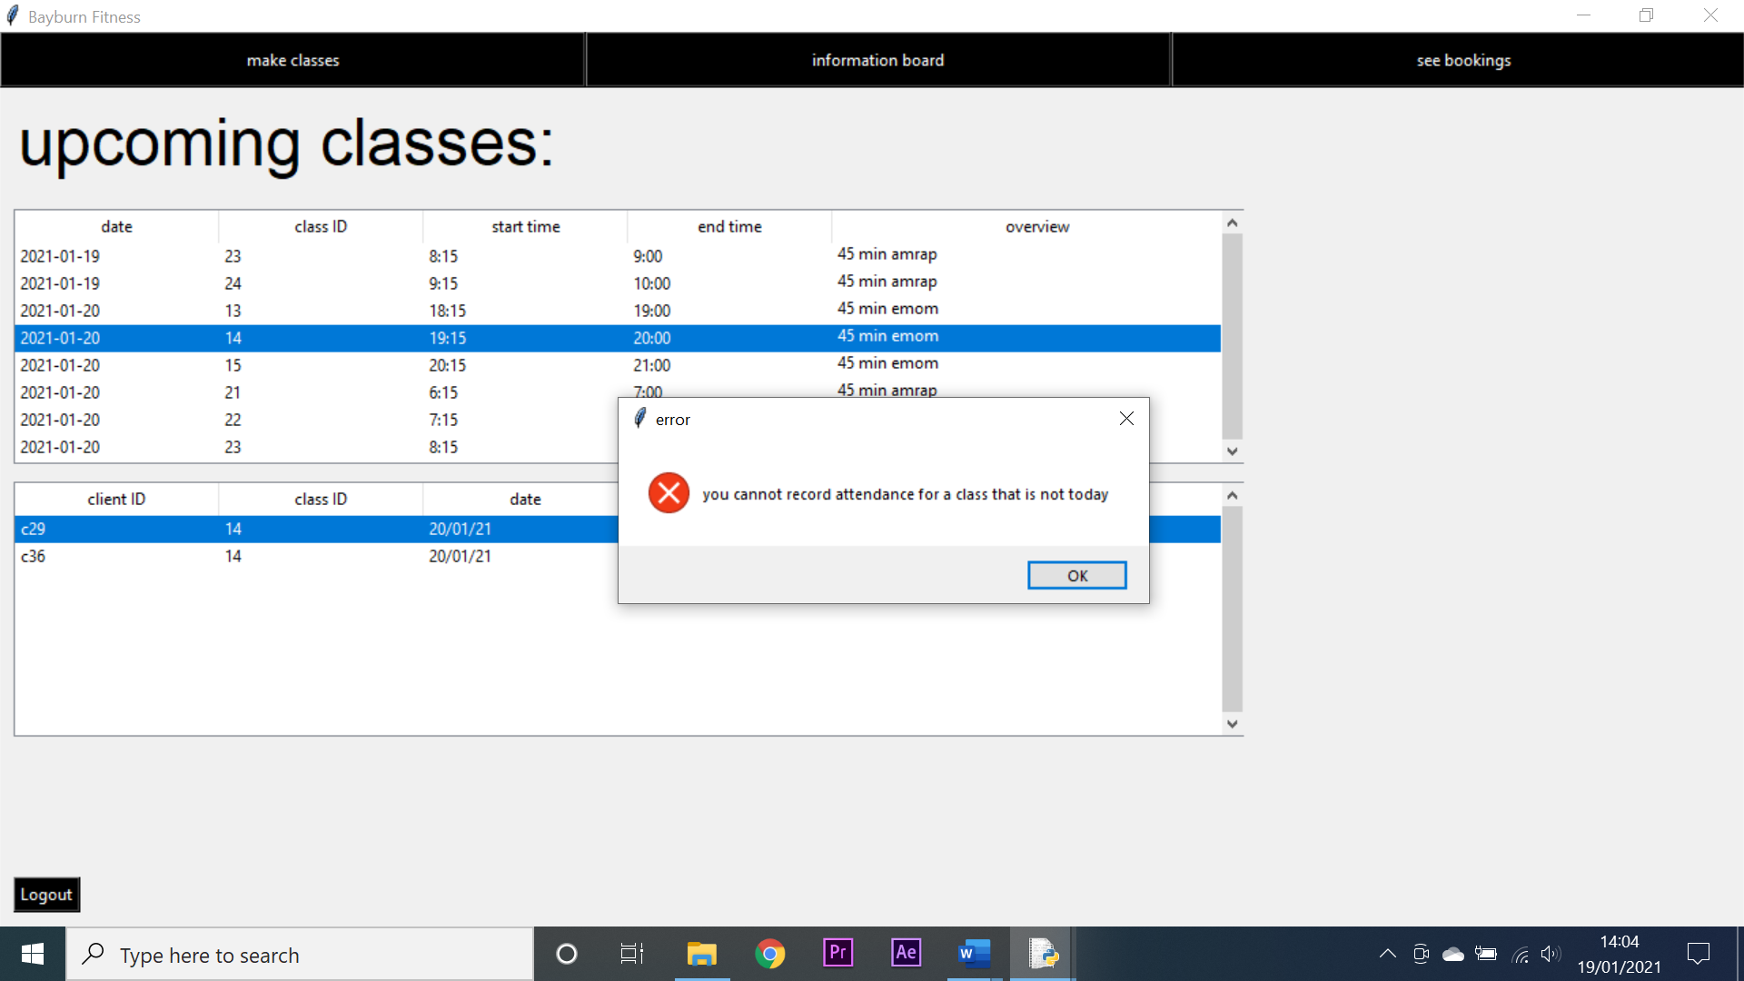

4 - successful

**Testing trainer screen navigation:**

|  |  |  |  |  |  |  |  |
| --- | --- | --- | --- | --- | --- | --- | --- |
| Test number | System requirement | Test data type | Test data | Expected outcome | Observed outcome | Match | Comments |
| 1 | create an intuitive GUI through which my system can be navigated | Valid | I attempted to navigate to the make a class screen | I would arrive at the make a class screen | I arrived at the make a class screen | Yes | N/A |
| 2 | create an intuitive GUI through which my system can be navigated | Valid | I attempted to navigate to the information board screen | I would arrive at the information board screen | I arrived at the information board screen | Yes | N/A |
| 3 | create an intuitive GUI through which my system can be navigated | Valid | I attempted to navigate to the view bookings screen | I would arrive at the view bookings screen | I arrived at the view bookings screen | Yes | N/A |
| 4 | create an intuitive GUI through which my system can be navigated | Valid | I attempted to logout | I would arrive at the login screen | I arrived at the login screen | Yes | N/A |

**Test screenshots:**

2

1

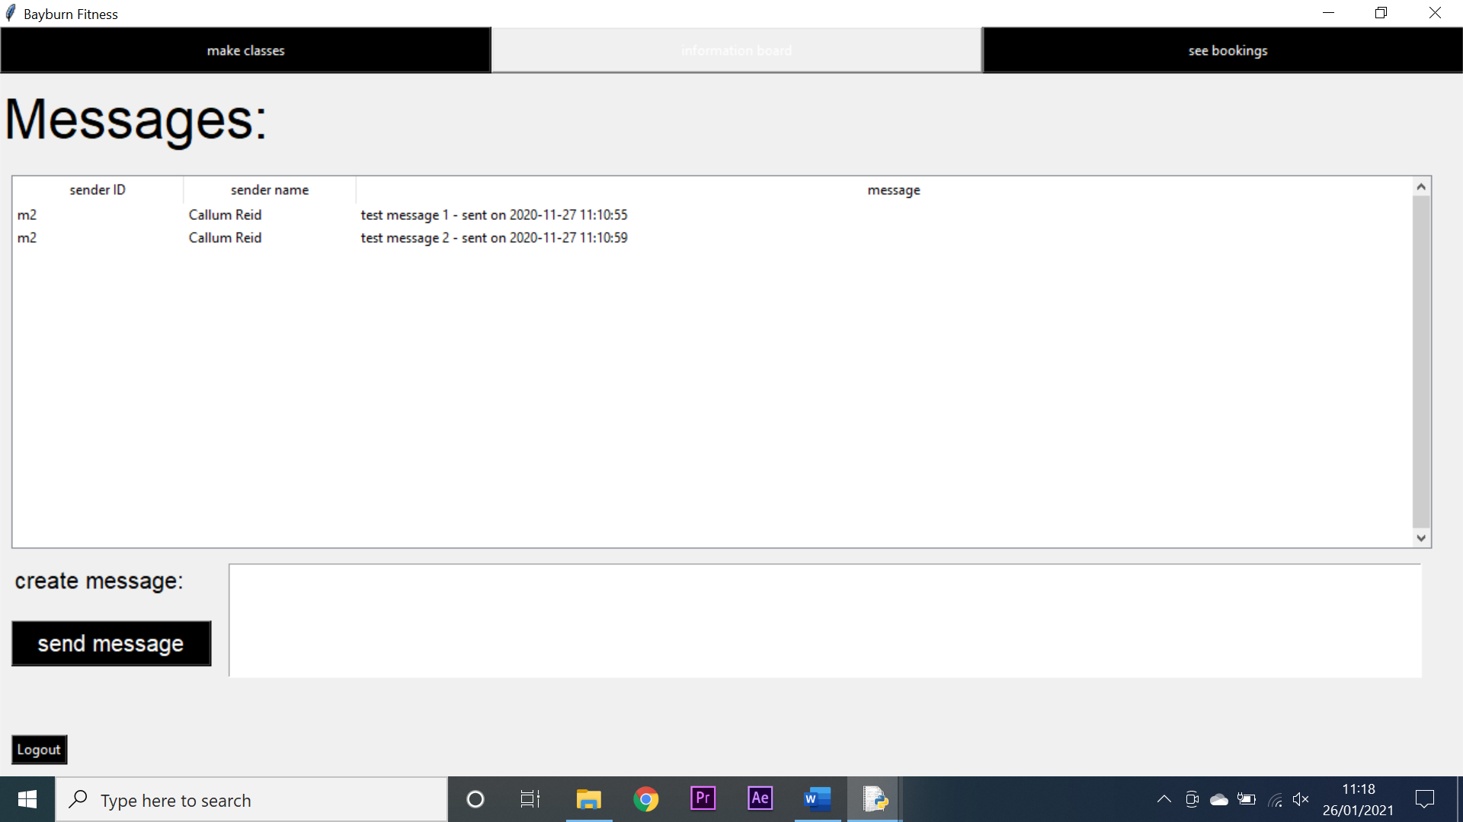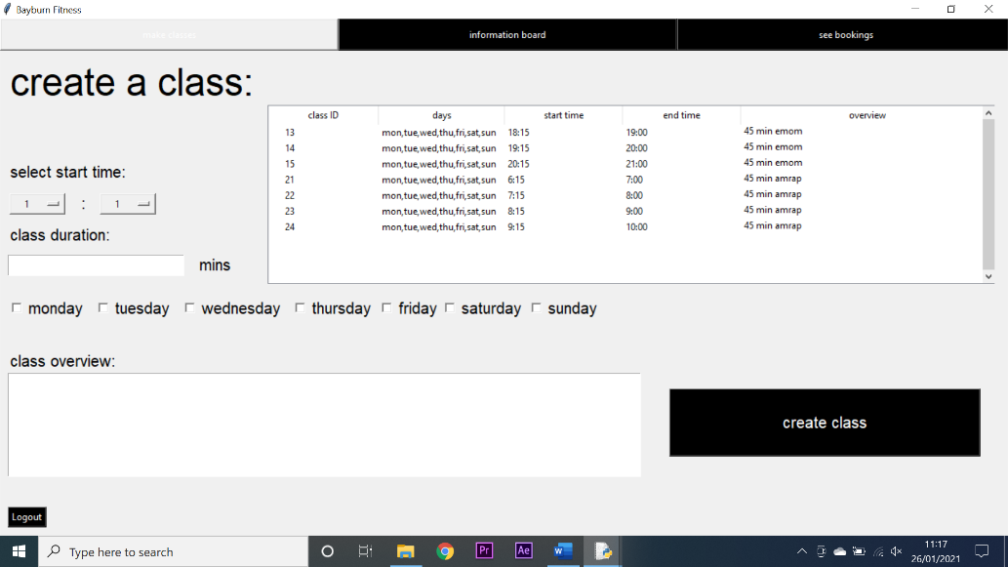

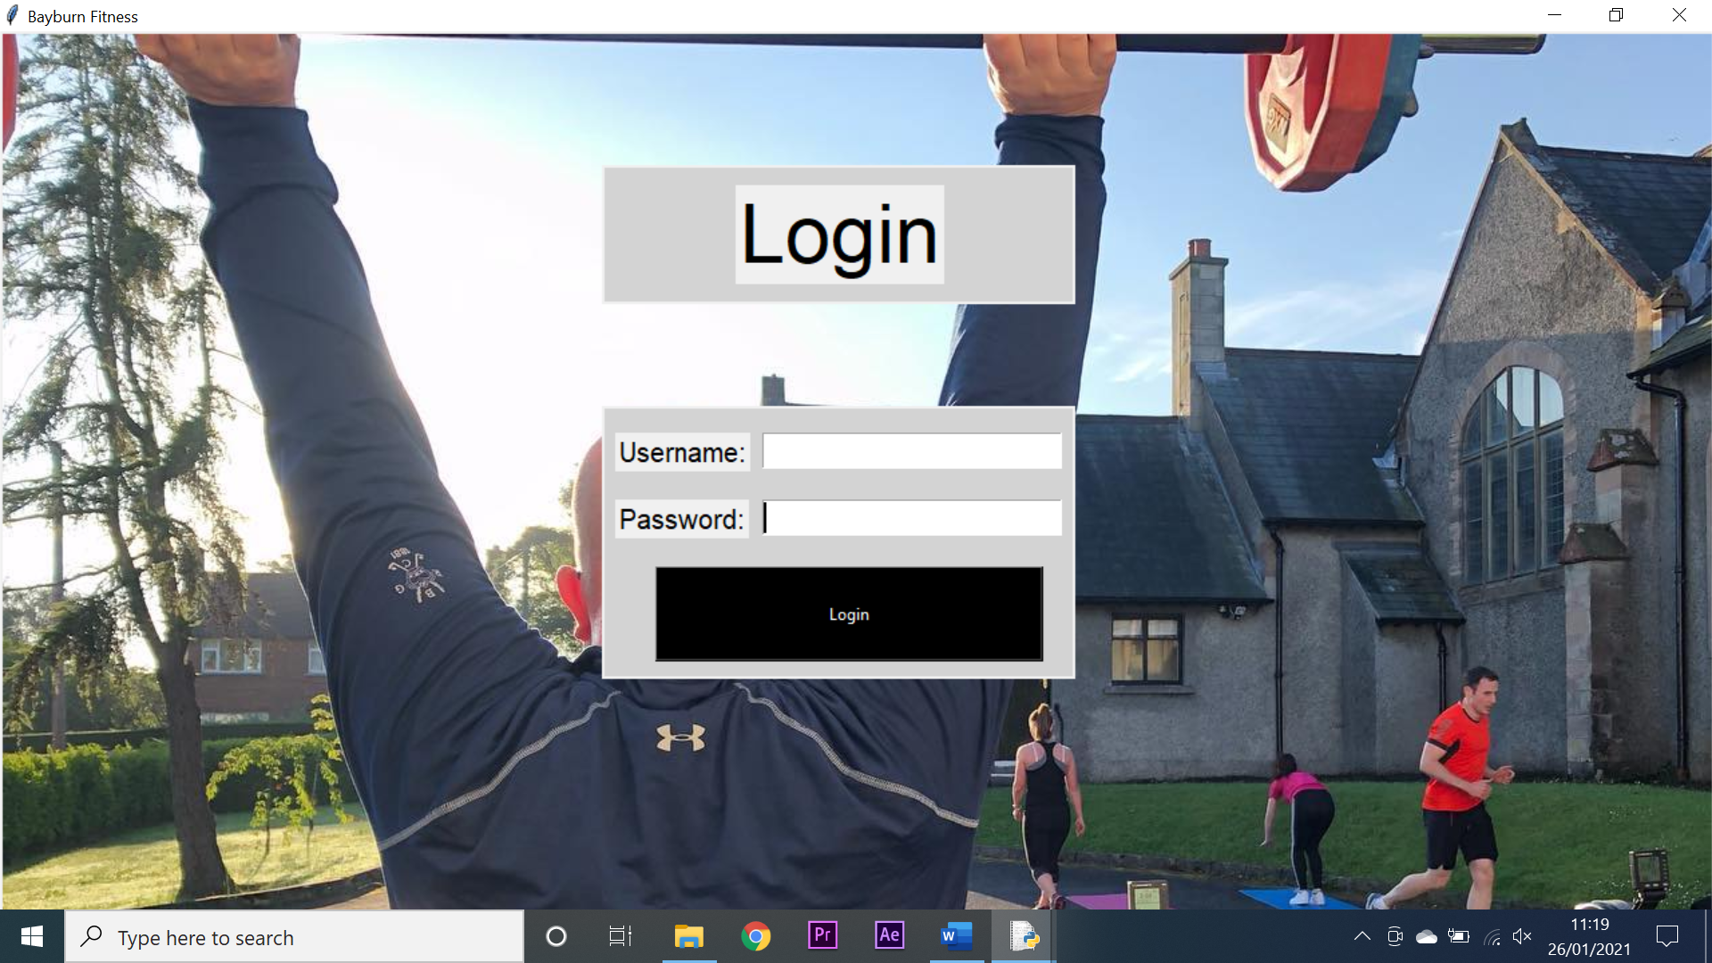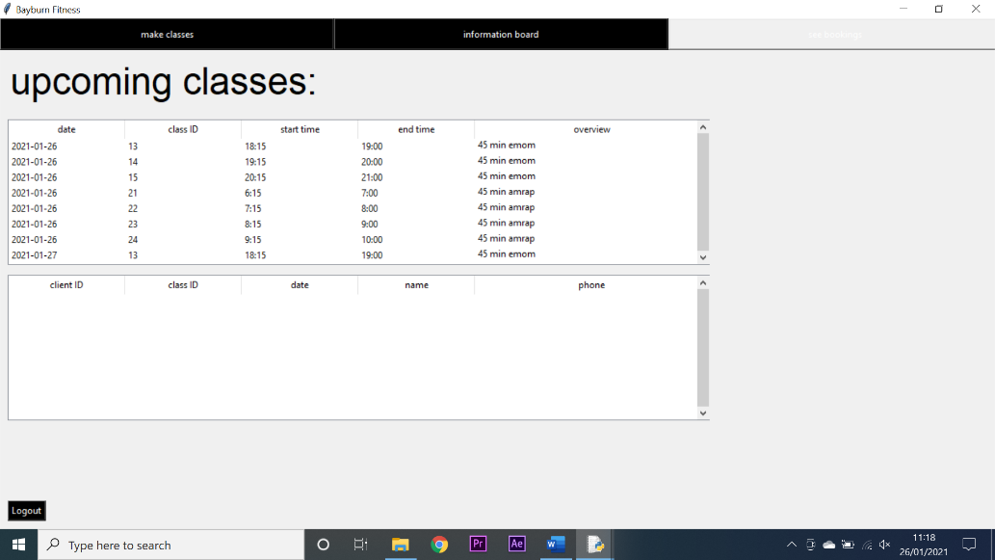

4

3

**Testing manager create person functionality:**

|  |  |  |  |  |  |  |  |
| --- | --- | --- | --- | --- | --- | --- | --- |
| Test number | System requirement | Test data type | Test data | Expected outcome | Observed outcome | Match | Comments |
| 1 | create a system that allows managers to add, edit and delete stakeholders from the system with ease | Valid | A fully valid collection of data was entered into the screen and the add person button was pressed | The person would be added to the system | The person was added to the system | Yes | N/A |
| 2 | create a system that allows managers to add, edit and delete stakeholders from the system with ease | null | No data was entered into any of the fields and the add person button was pressed | Error messages would appear alerting the user to all the blank fields | Error messages appeared alerting the user to all the blank fields | Yes | N/A |
| 3 | create a system that allows managers to add, edit and delete stakeholders from the system with ease | invalid | A phone number was entered that was not 11 digits long | An error message would appear | An error message appeared | Yes | N/A |
| 4 | create a system that allows managers to add, edit and delete stakeholders from the system with ease | invalid | A phone number was entered that contained letters | An error message would appear | An error message appeared | Yes | N/A |
| 5 | create a system that allows managers to add, edit and delete stakeholders from the system with ease | invalid | A first name and surname was entered that contained numbers | Two error messages would appear alerting the user to both errors | Two error messages appeared alerting the user to both errors | Yes | N/A |
| 6 | create a system that allows managers to add, edit and delete stakeholders from the system with ease | invalid | An email was entered that did not have an @ symbol | An error message would be generated alerting the user to the issue | An error message was generated alerting the user to the issue | Yes | N/A |
| 7 | create a system that allows managers to add, edit and delete stakeholders from the system with ease | invalid | A username was entered that had already been used | An error message would be generated alerting the user to the issue | An error message was generated alerting the user to the issue | Yes | N/A |
| 8 | create a system that allows managers to add, edit and delete stakeholders from the system with ease | invalid | A password was entered that was less than 8 characters | An error message would be generated alerting the user to the issue | An error message was generated alerting the user to the issue | Yes | N/A |
| 9 | create a system that allows managers to add, edit and delete stakeholders from the system with ease | invalid | When creating a client the height and weight were entered as letters instead of numbers | Error messages would be generated alerting the user to the issue | Error messages were generated alerting the user to the issue | Yes | N/A |
| 10 | create a system that allows managers to add, edit and delete stakeholders from the system with ease | valid | The clear all button was pressed | All fields would be cleared of data | All fields were cleared of data | Yes | N/A |
| 11 | create a system that allows managers to add, edit and delete stakeholders from the system with ease | valid | The edit a person button was pressed | The search screen would appear | The search screen appeared | Yes | N/A |
| 12 | create a system that allows managers to access the information associated with any individual client or trainer | valid | Data was entered into the three search fields | The treeview would refine its search appropriately | The treeview refined its search appropriately | Yes | N/A |
| 13 | create a system that allows managers to access the information associated with any individual client or trainer | valid | A person was selected from the search treeview | All of the selected person’s data would be entered into the appropriated entry fields | All of the selected person’s data was entered into the appropriated entry fields | Yes | N/A |
| 14 | create a system that allows managers to add, edit and delete stakeholders from the system with ease | valid | Data from a selected person was changed and re-submitted | The person would be re-added to the system with their new data | The person was re-added to the system with their new data | Yes | N/A |
| 15 | create a system that allows managers to add, edit and delete stakeholders from the system with ease | valid | A person was selected and the delete person button was pressed | The person would be deleted from the database | The person was not deleted from the database | No | This was a problem with the MYSQL statement. Once rectified the test was repeated and was successful |

**Test screenshots:**

2

1

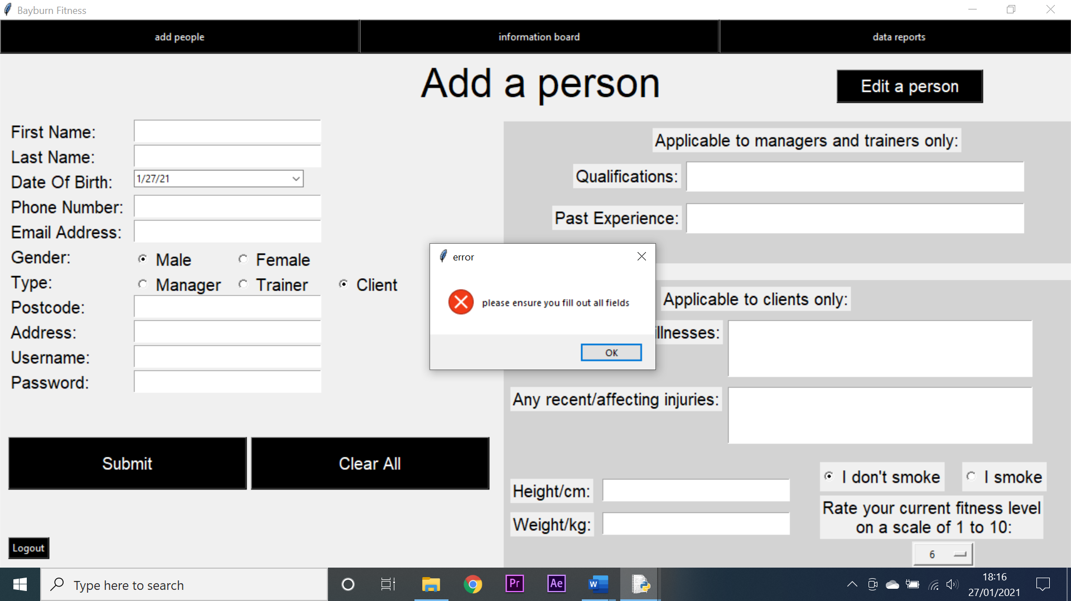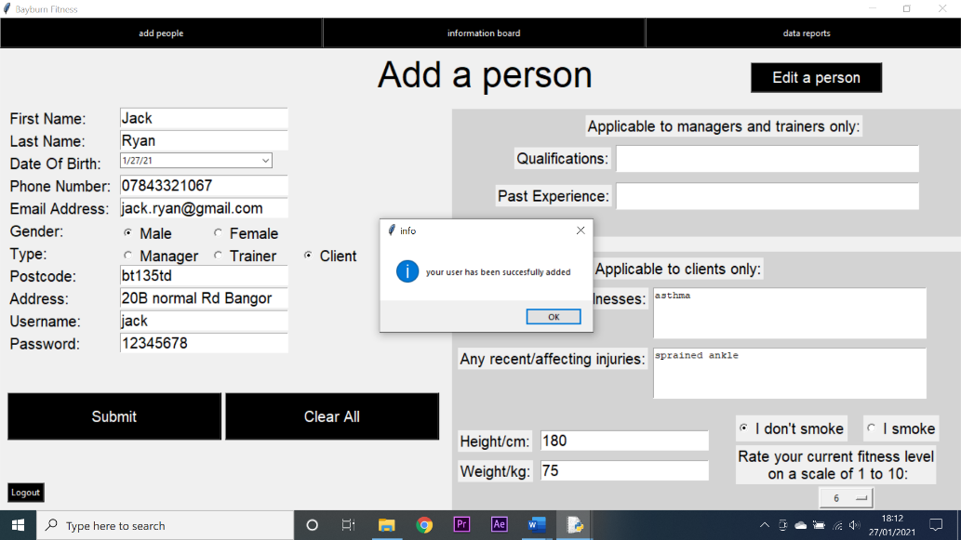

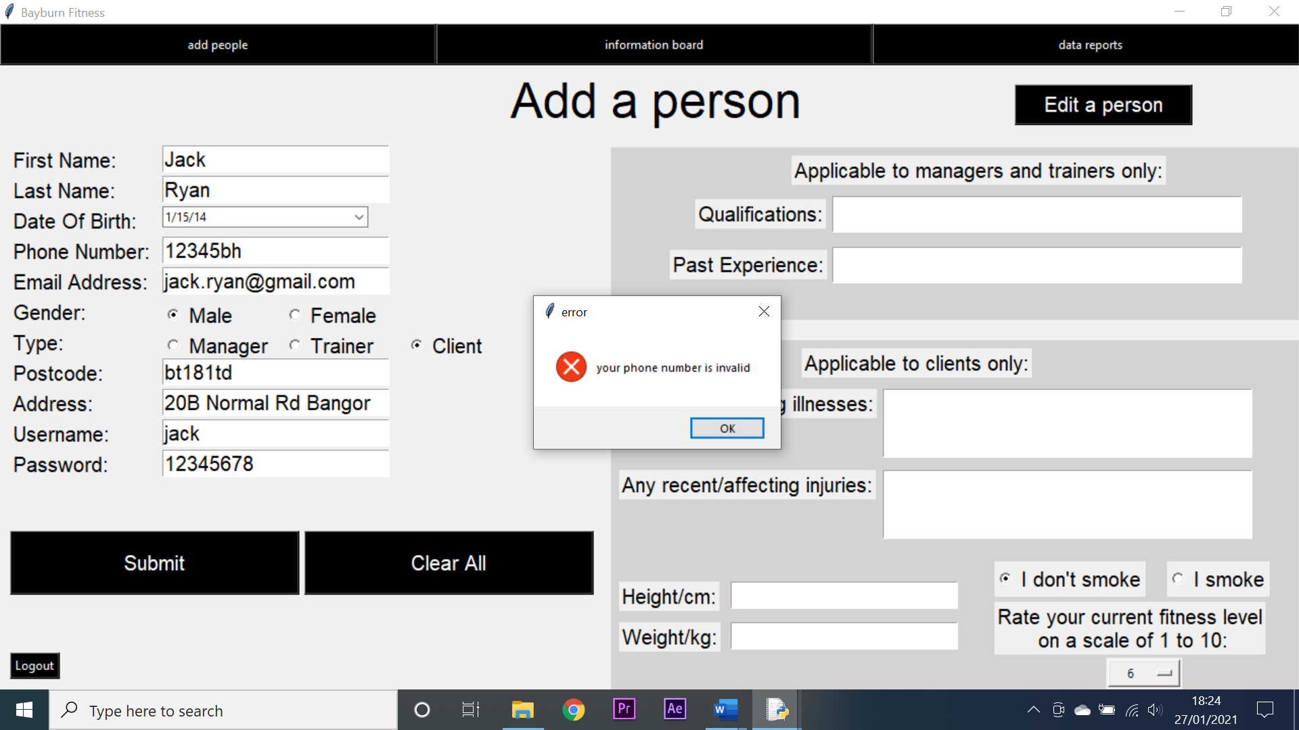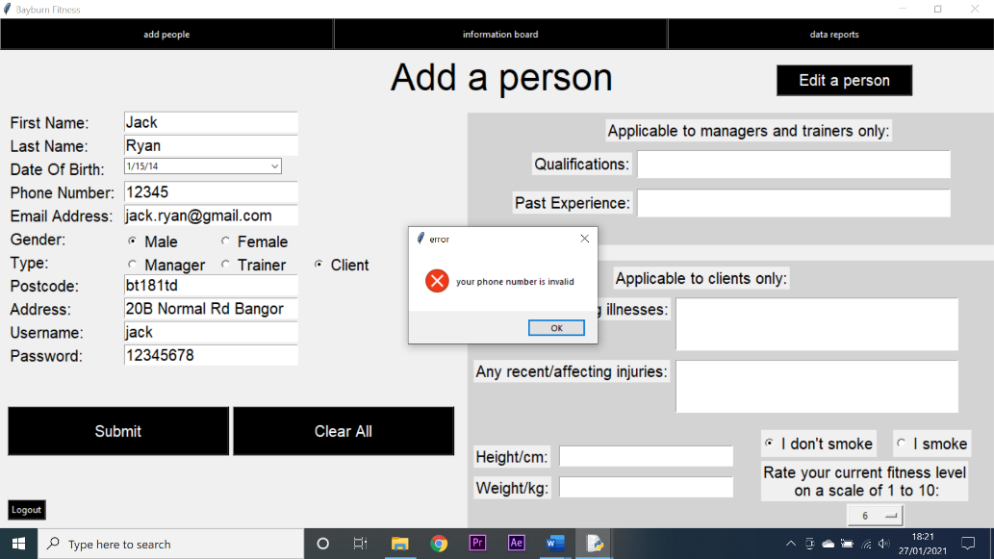

4

3

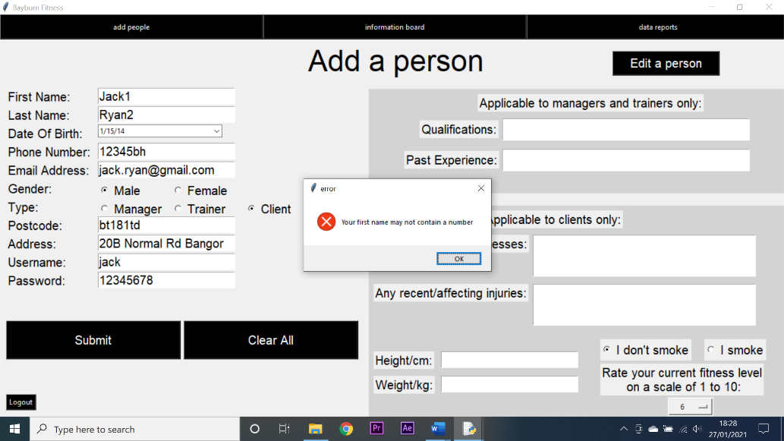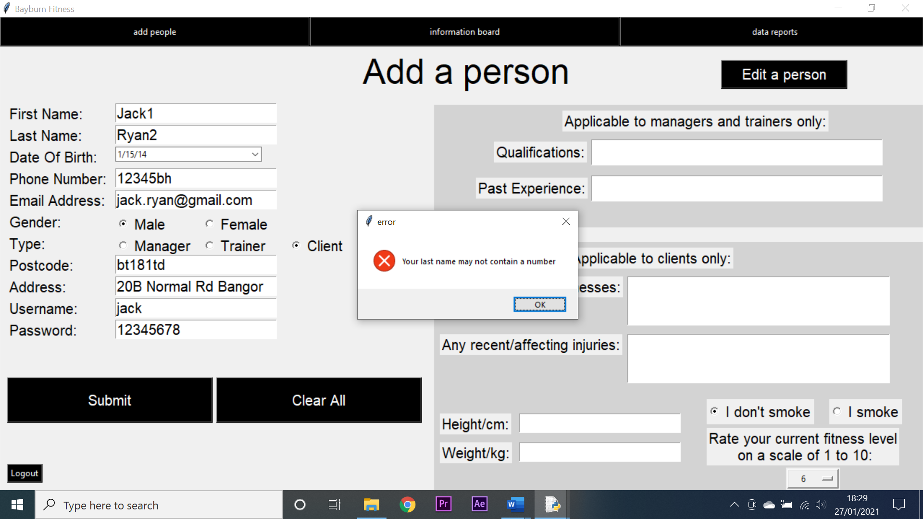

7

6

5

5

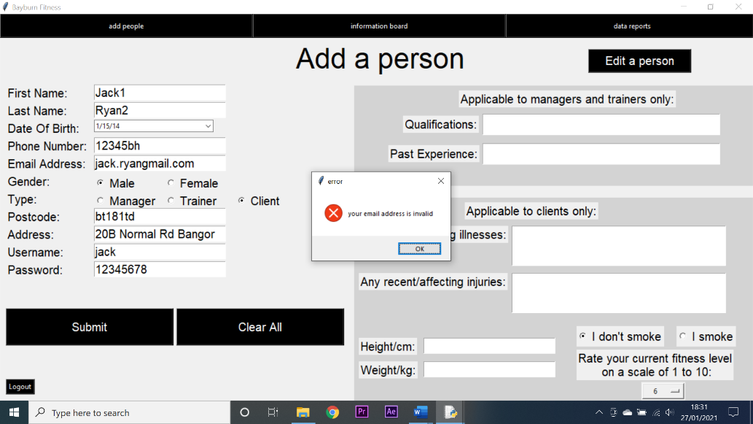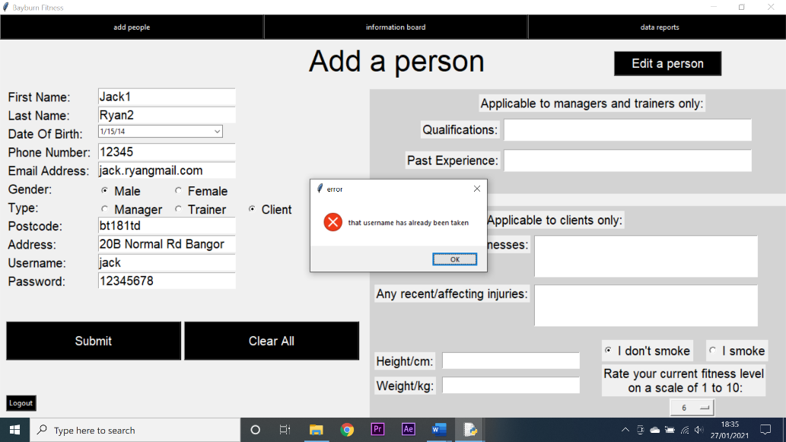

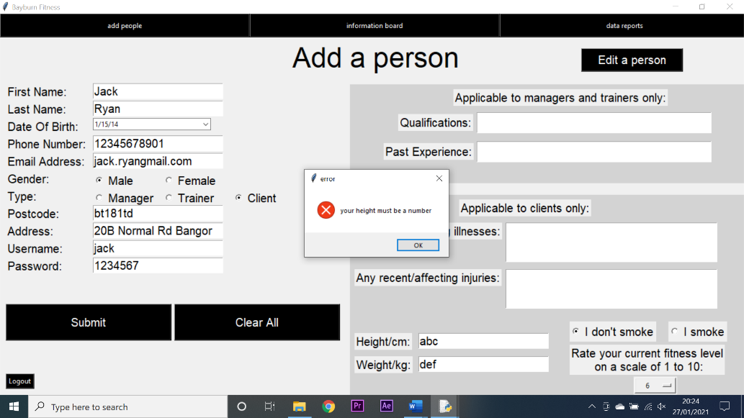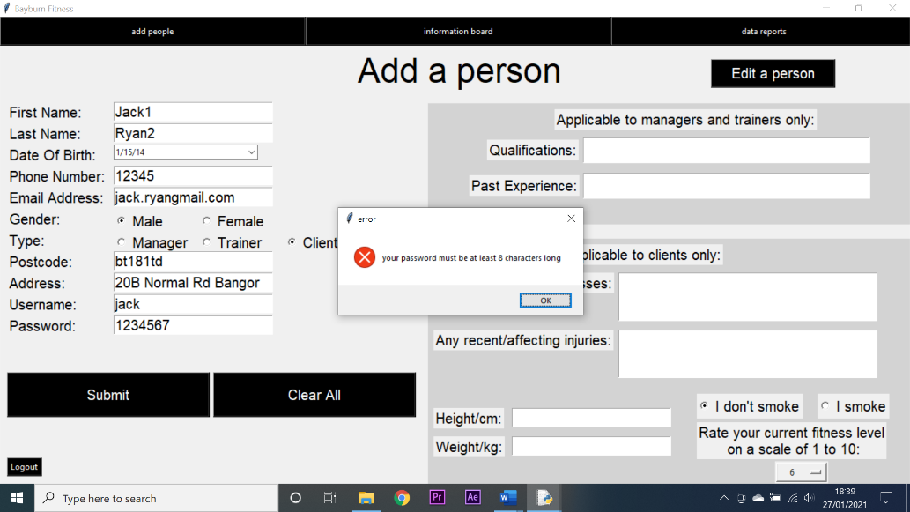

9

8

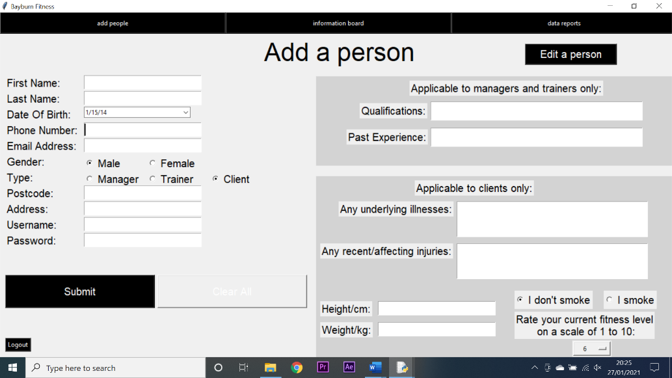

9

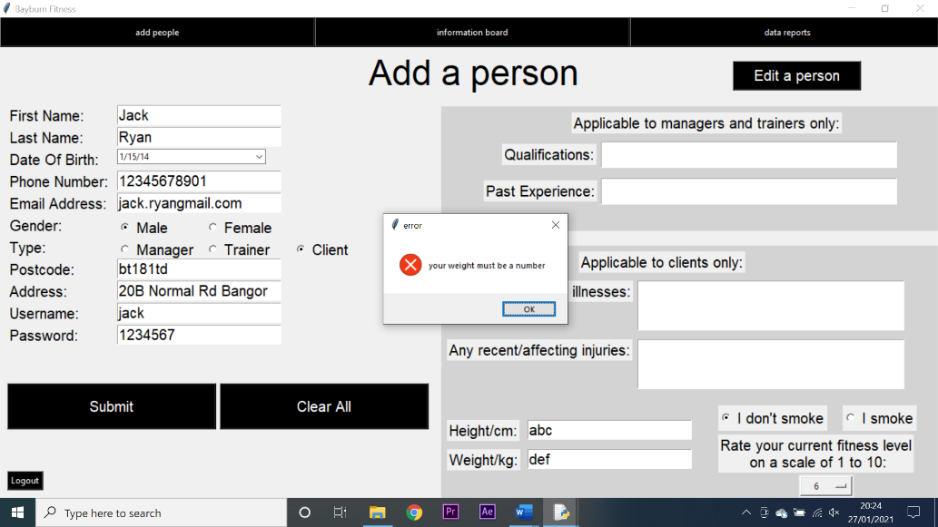

10

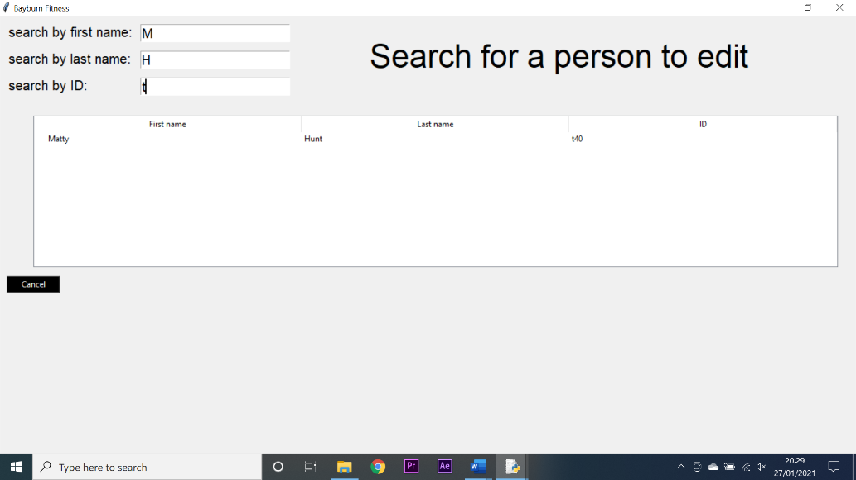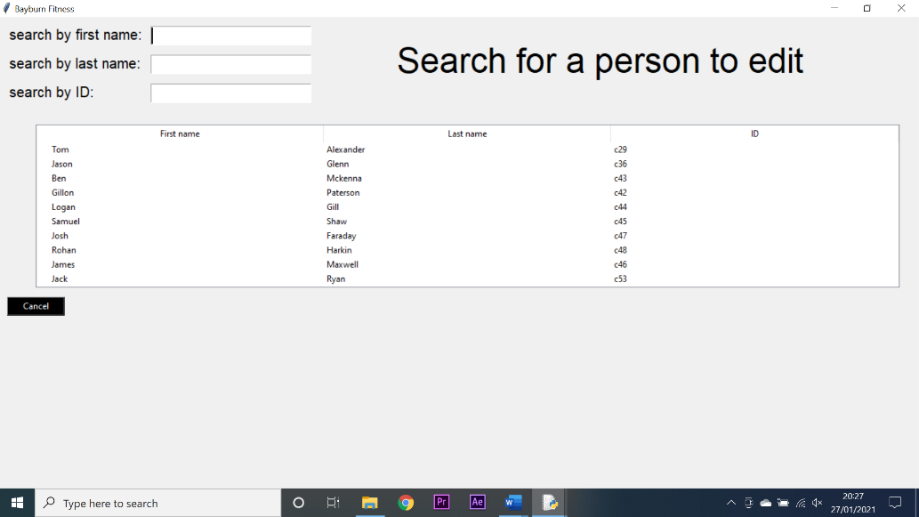

12

11

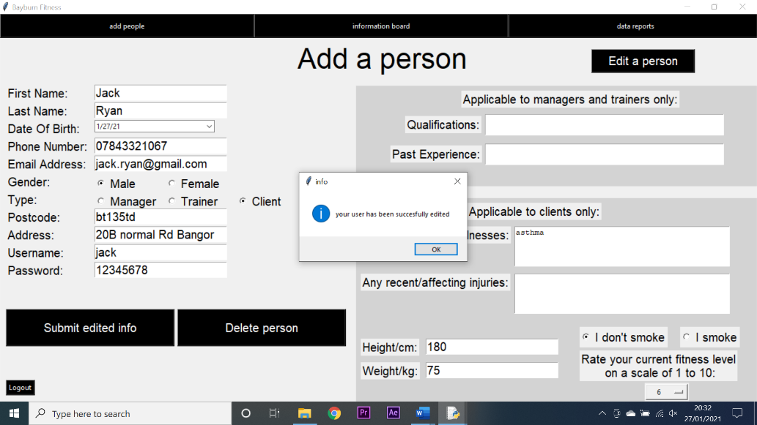

14

13

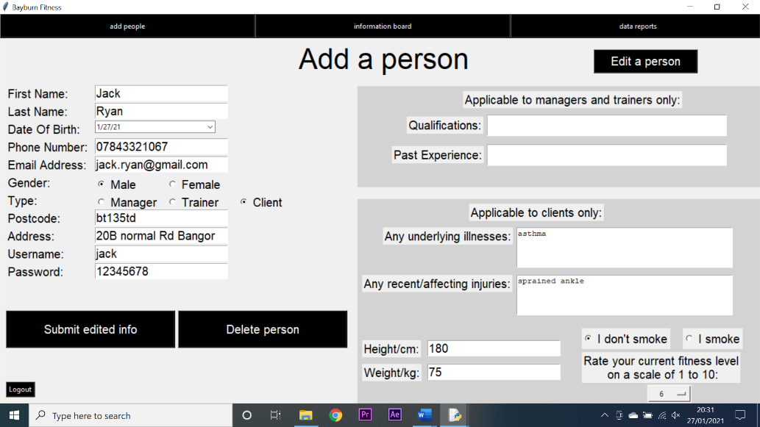

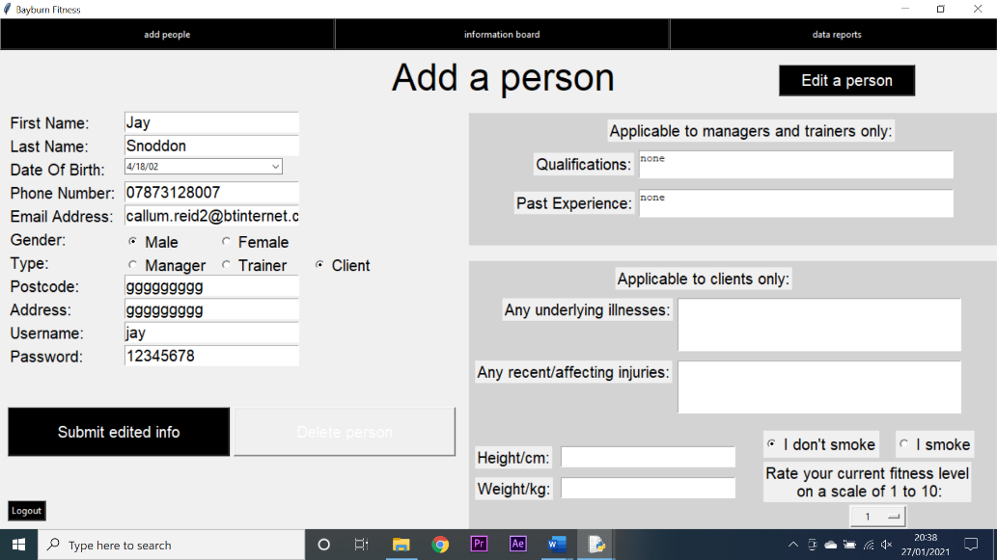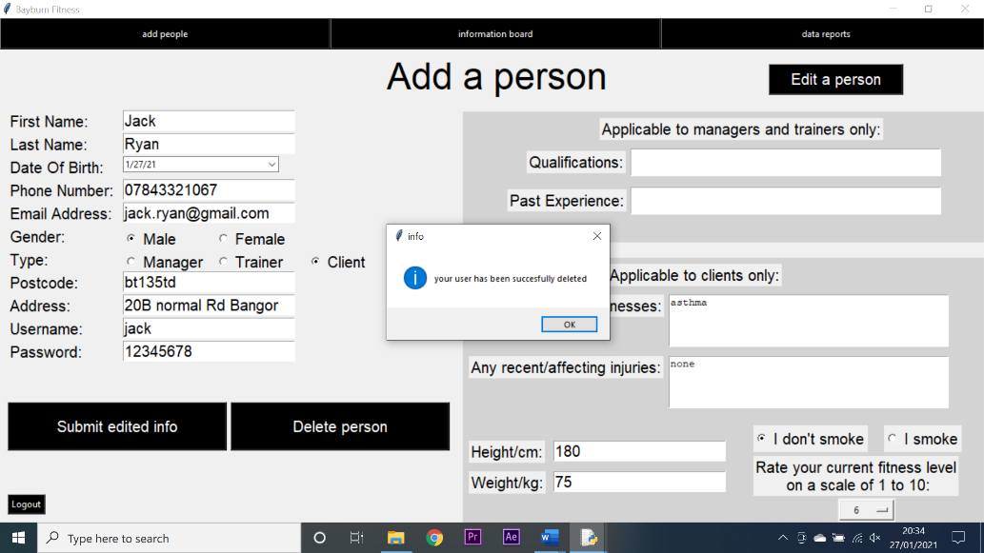

15 - successful

15 - failed

**Testing manager message board functionality:**

|  |  |  |  |  |  |  |  |
| --- | --- | --- | --- | --- | --- | --- | --- |
| Test number | System requirement | Test data type | Test data | Expected outcome | Observed outcome | Match | Comments |
| 1 | create a system that allows managers to communicate easily and remotely with clients and trainers | Valid | A test message was entered and then sent | The message would appear on the board | The message appeared on the board | Yes | N/A |
| 2 | create a system that allows managers to communicate easily and remotely with clients and trainers | Null | No data was entered, and the send message button was pressed | An error message would appear | An error message appeared | Yes | N/A |
| 3 | create a system that allows managers to communicate easily and remotely with clients and trainers | Valid | A message was selected that was not sent by the manager I was logged in as | The message would be displayed in an info box | The message was displayed in an info box | Yes | N/A |
| 4 | create a system that allows managers to communicate easily and remotely with clients and trainers | Valid | A message sent by the manager currently logged in was selected to be deleted | A question box would appear allowing the user to delete the message | A question box appeared allowing the user to delete the message | Yes | N/A |

**Test screenshots:**

1

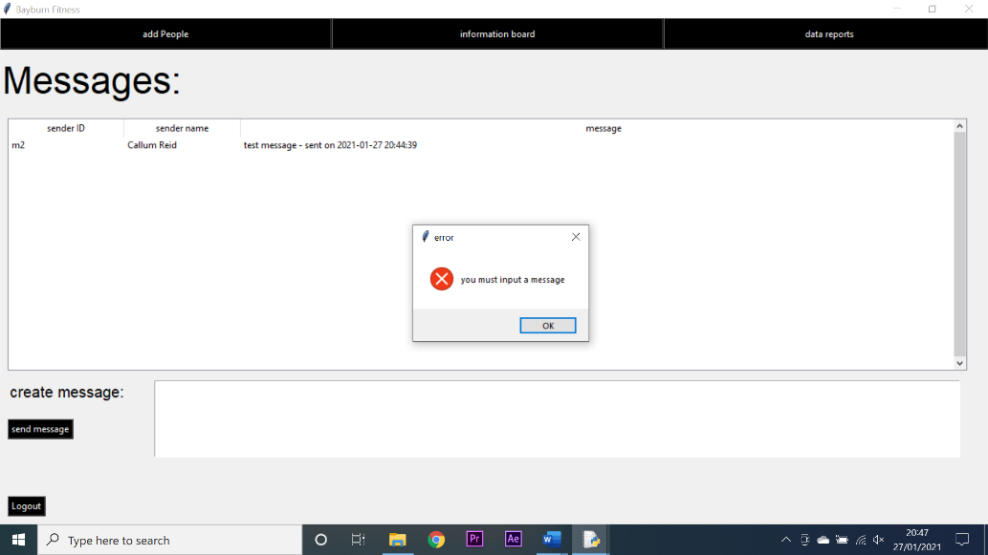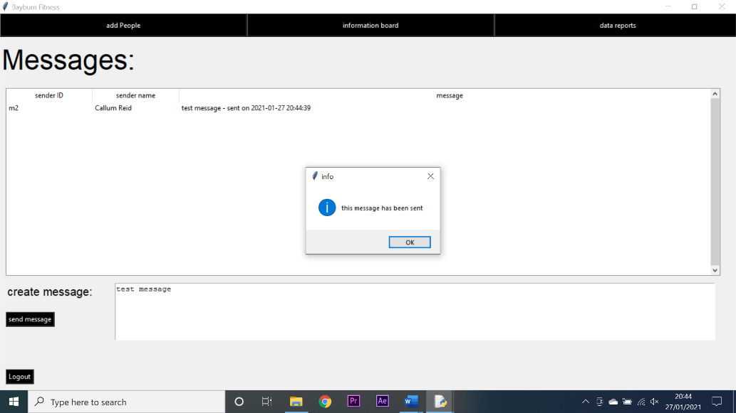

2

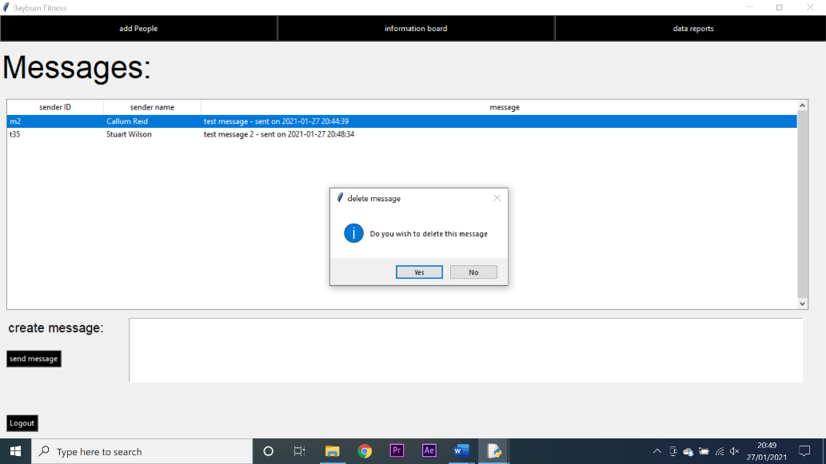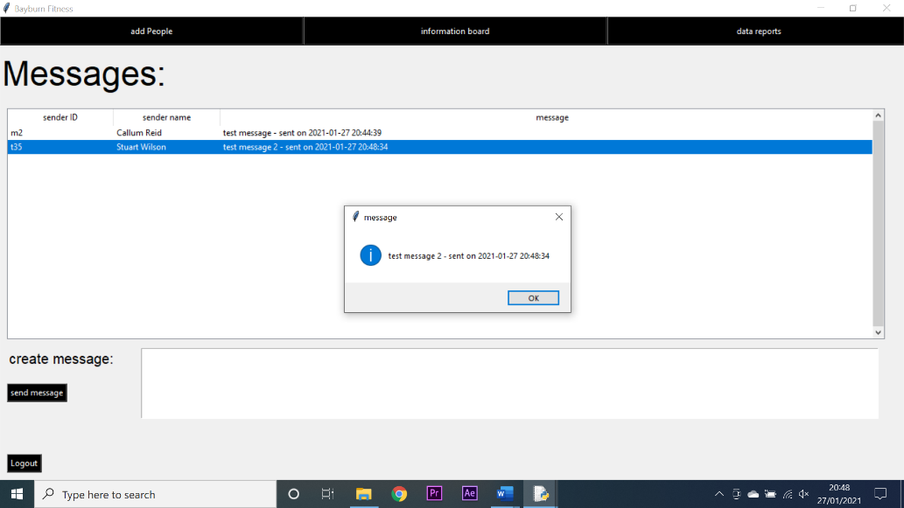

4

3

**Testing manager message board functionality:**

|  |  |  |  |  |  |  |  |
| --- | --- | --- | --- | --- | --- | --- | --- |
| Test number | System requirement | Test data type | Test data | Expected outcome | Observed outcome | Match | Comments |
| 1 | create a system that allows a manager to generate in depth reports on class attendance and who has paid for their classes | Invalid | No option was selected, and the show graph button was pressed | An error message would be generated | An error message was generated | Yes | N/A |
| 2 | create a system that allows a manager to generate in depth reports on class attendance and who has paid for their classes | Valid | The trainer attendance option was selected and the show button was pressed | A graph would be generated | A graph was generated | Yes | N/A |
| 3 | create a system that improves the organisation and availability of data | Valid | The attendance vs times option was selected | A graph would be generated | A graph was generated | Yes | N/A |
| 4 | create a system that allows a manager to generate in depth reports on class attendance and who has paid for their classes | Valid | The attendance (last 30 days) option was selected | A graph would be generated | A graph was generated | Yes | N/A |
| 5 | create a system that allows a manager to generate in depth reports on class attendance and who has paid for their classes | Valid | The attendance vs class type option was selected | A chart would be generated | A chart was generated | Yes | N/A |
| 6 | create a system that allows managers to access the information associated with any individual client or trainer | Valid | One of the client fitness trackers was selected | A chart would be generated | A chart was generated | Yes | N/A |
| 7 | create a system that reduces the amount of overall paperwork needed to be done by a manager | Valid | One of the options was selected and the generate report button was pressed | A file dialogue box would open allowing me to save the file | No file dialogue box opened | No | This was a problem with the implementation of the file dialogue library. Once rectified the test was repeated and successful |

**Test screenshots:**

2

1

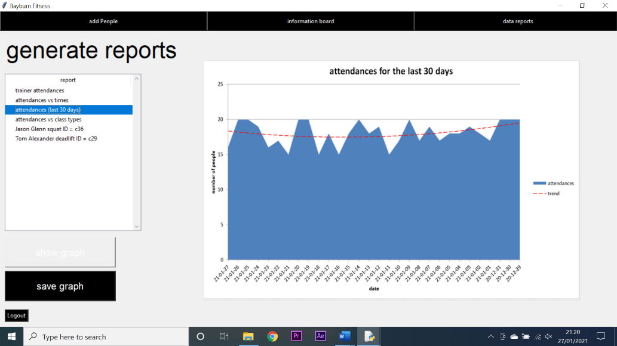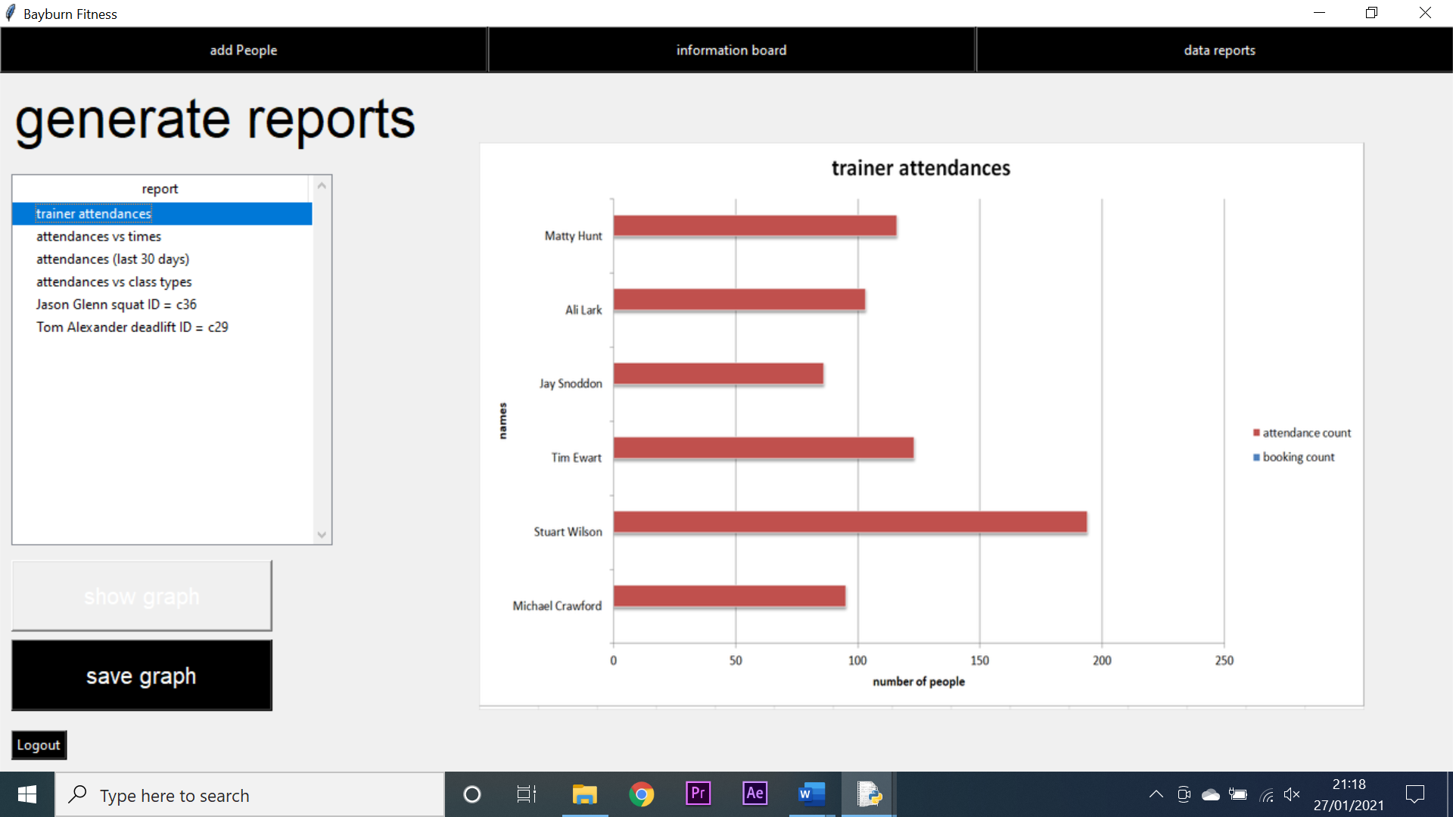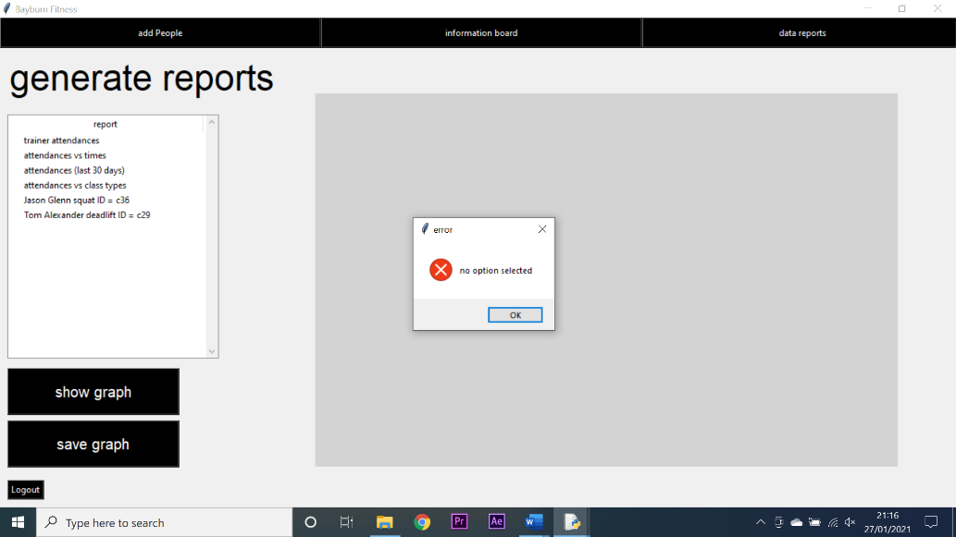

3

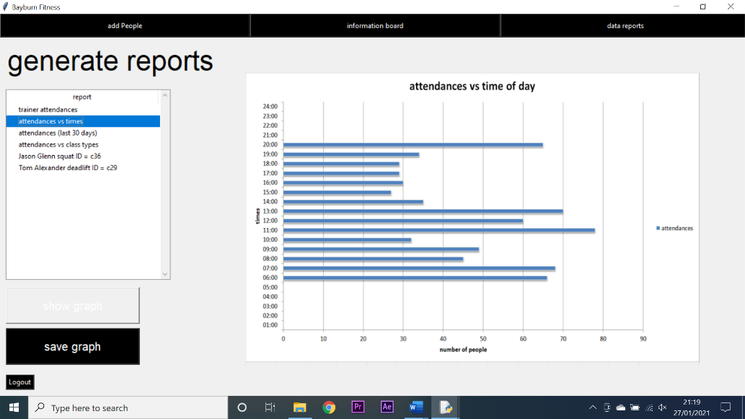

4

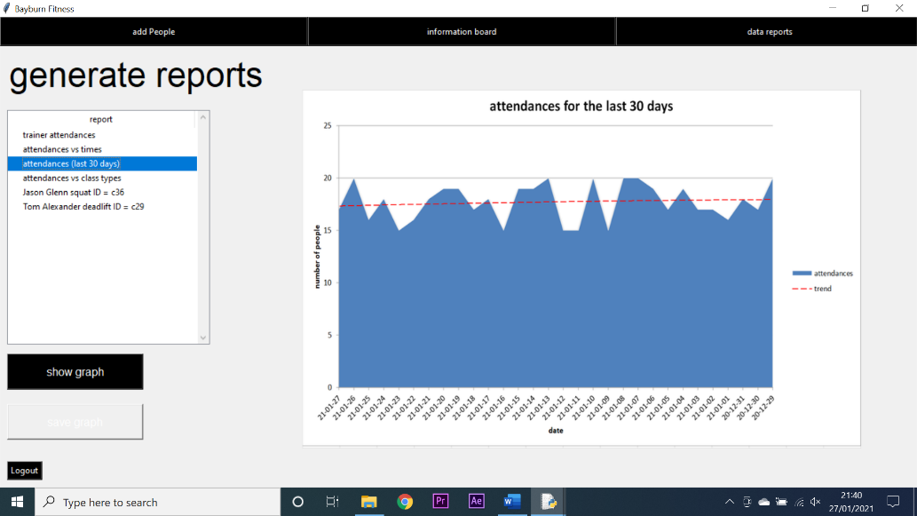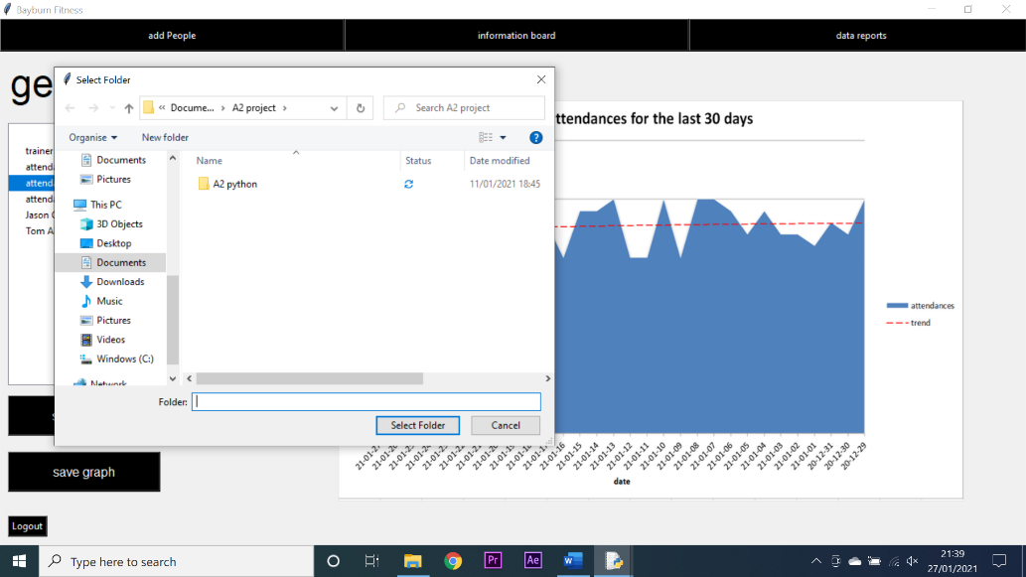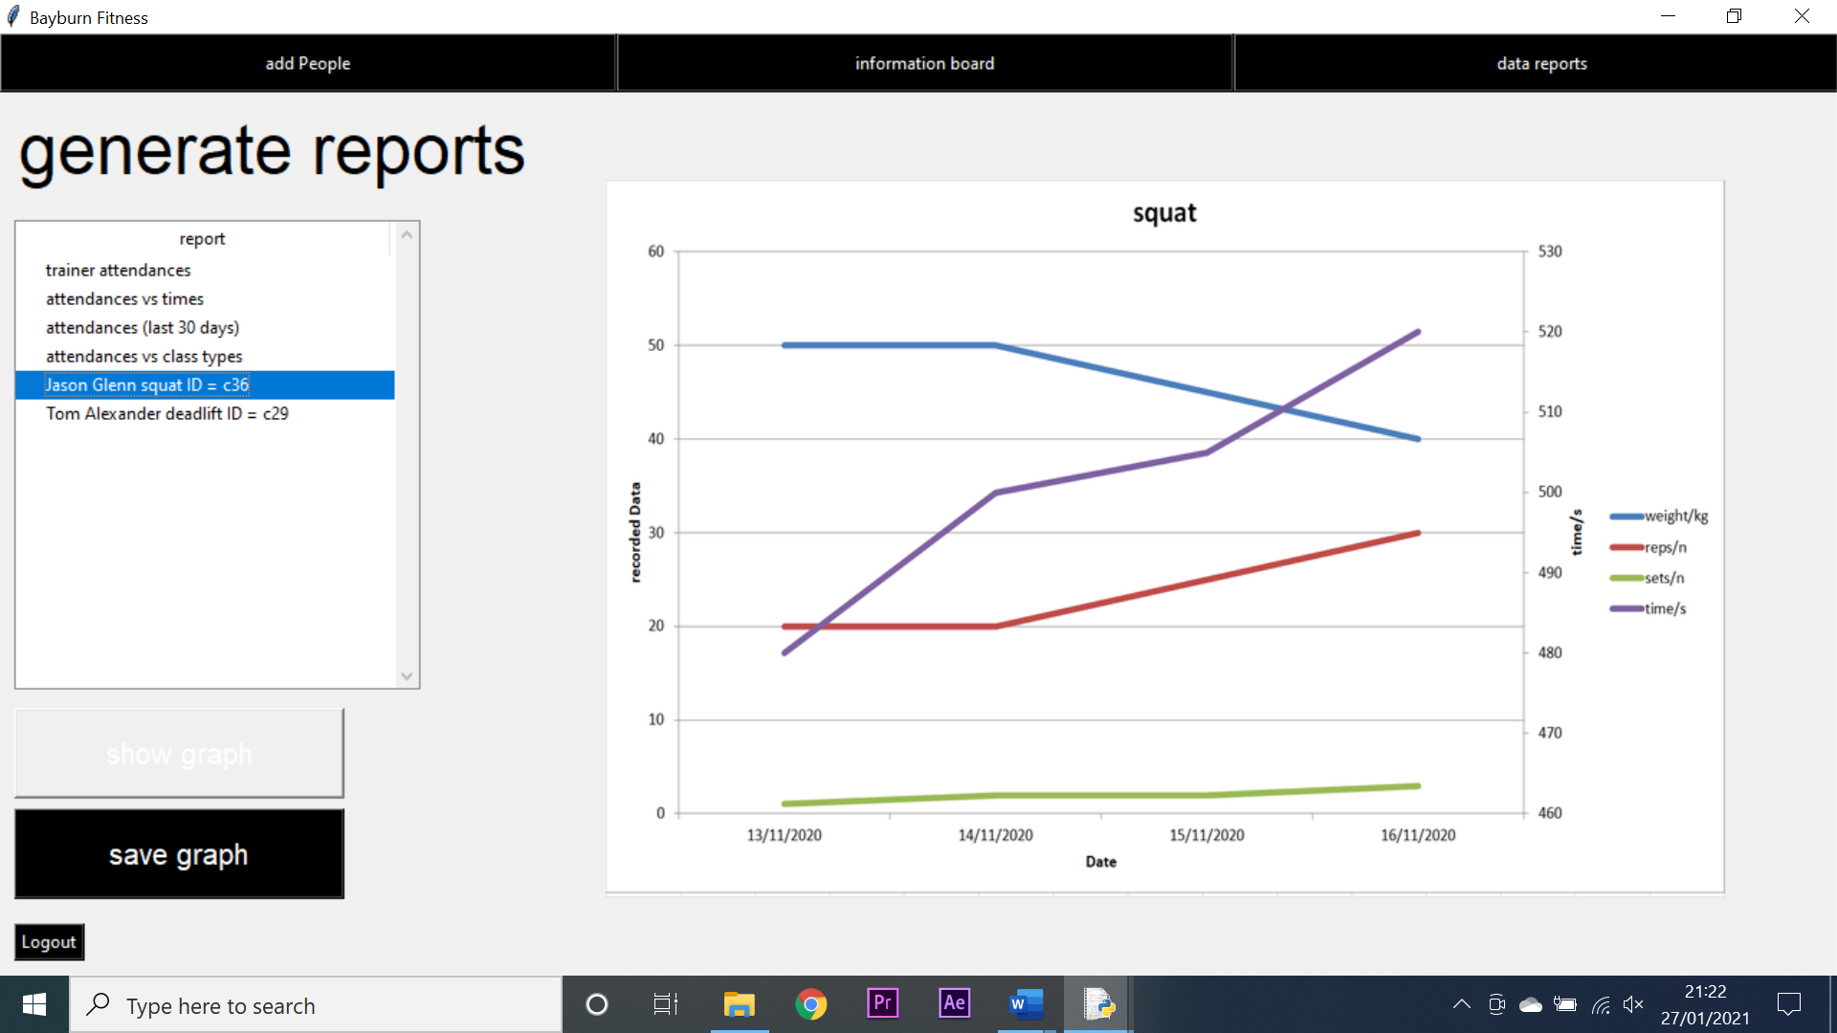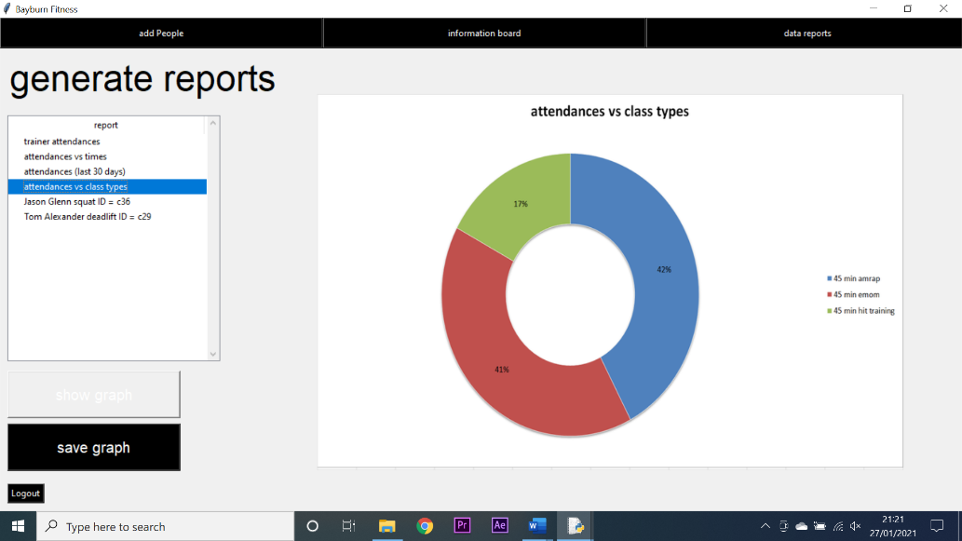

7 - successful

7 - failed

6

5

**Testing manager screen navigation:**

|  |  |  |  |  |  |  |  |
| --- | --- | --- | --- | --- | --- | --- | --- |
| Test number | System requirement | Test data type | Test data | Expected outcome | Observed outcome | Match | Comments |
| 1 | create an intuitive GUI through which my system can be navigated | Valid | I attempted to navigate to the add people screen | I would arrive at the add people screen | I arrived at the add people screen | Yes | N/A |
| 2 | create an intuitive GUI through which my system can be navigated | Valid | I attempted to navigate to the information board screen | I would arrive at the information board screen | I arrived at the information board screen | Yes | N/A |
| 3 | create an intuitive GUI through which my system can be navigated | Valid | I attempted to navigate to the data reports screen | I would arrive at the data reports screen | I arrived at the data reports screen | Yes | N/A |
| 4 | create an intuitive GUI through which my system can be navigated | Valid | I attempted to logout | I would arrive at the login screen | I did not arrive at the login screen | No | This was a problem with the raise frame function, once rectified the test was repeated and was successful |

**Test screenshots:**

2

1

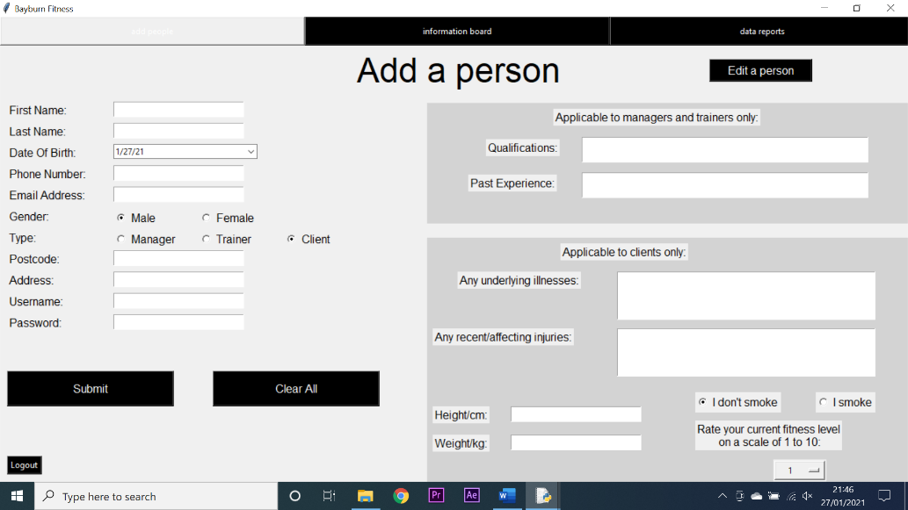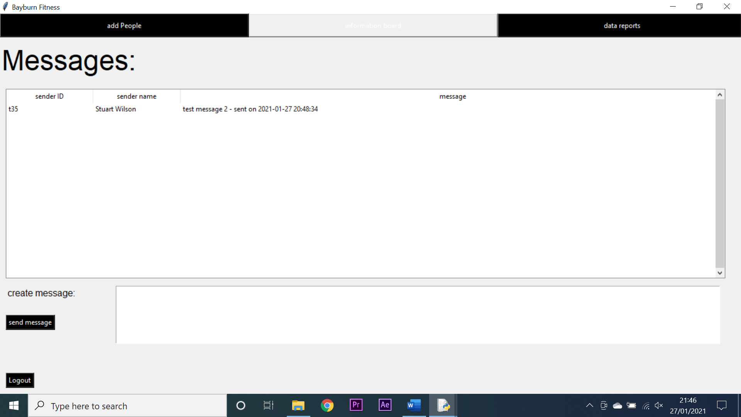

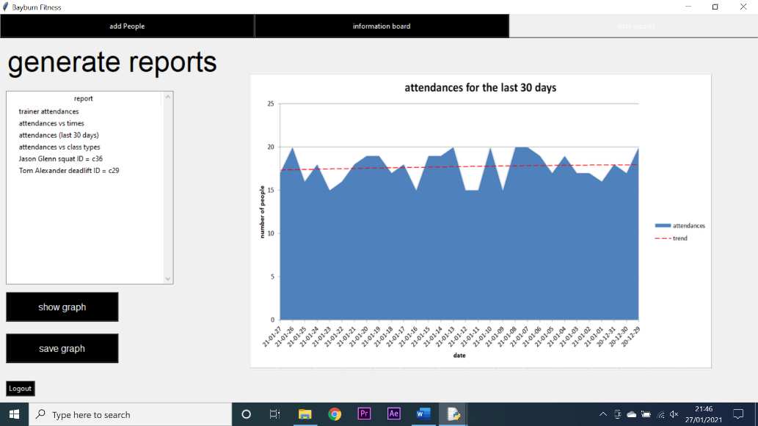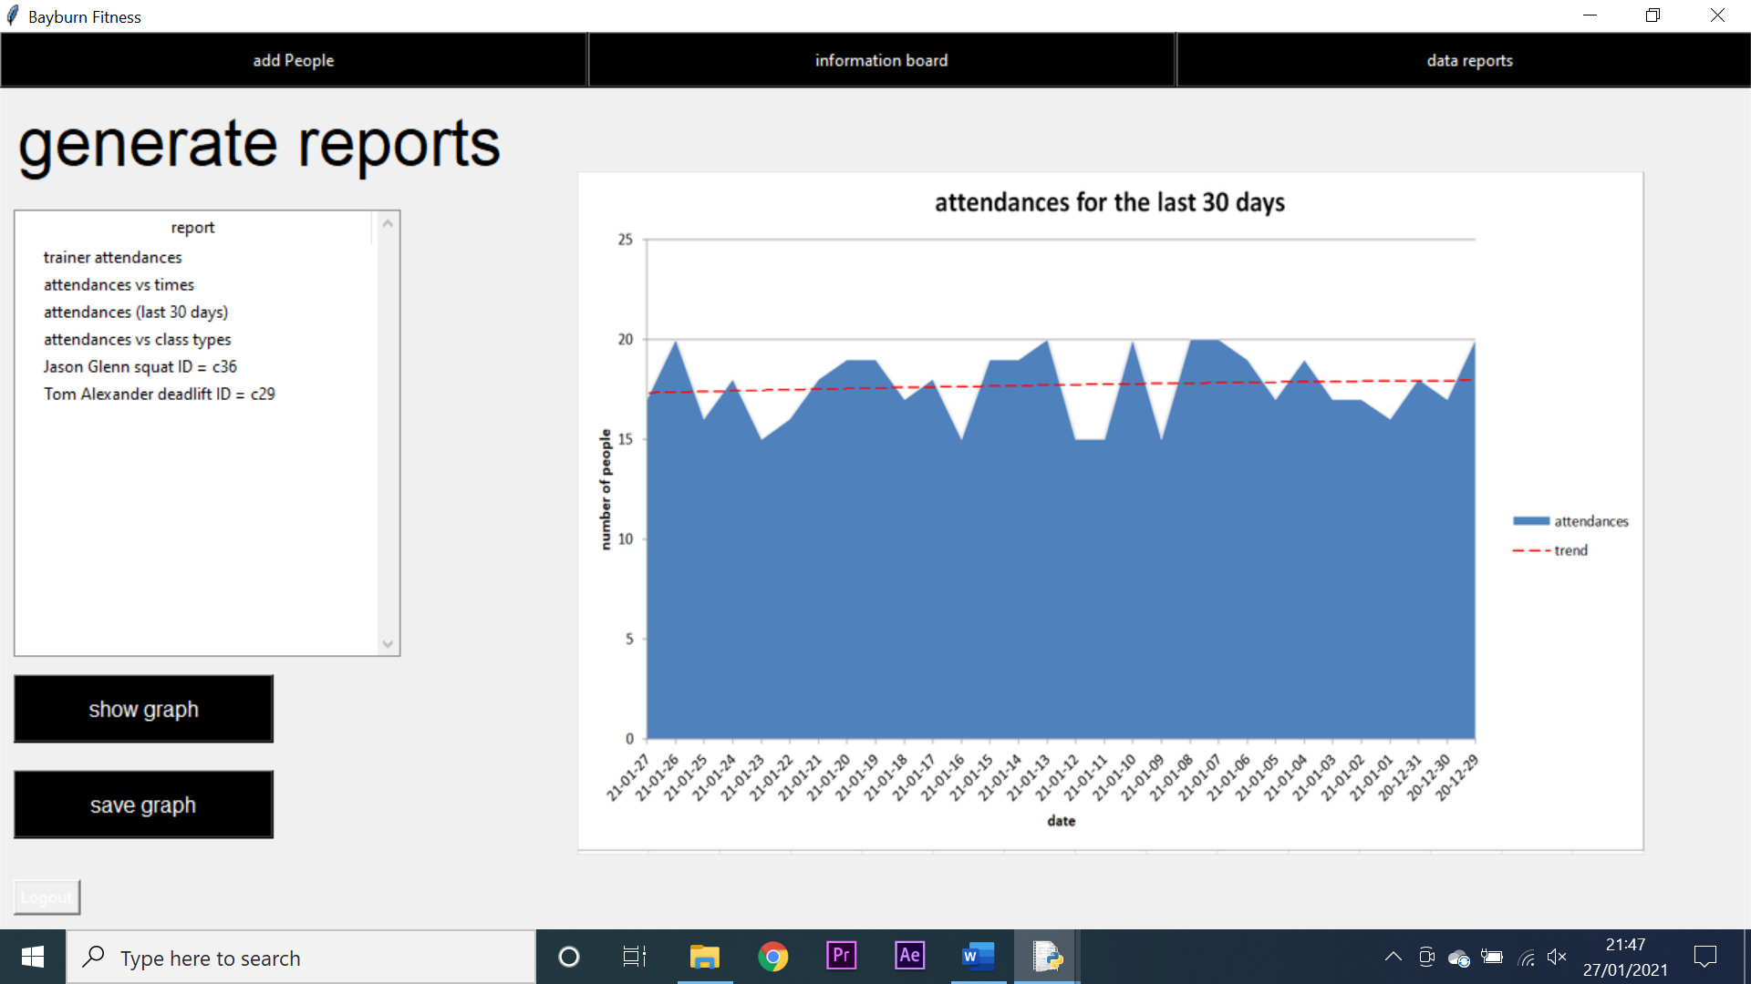

4 - failed

3

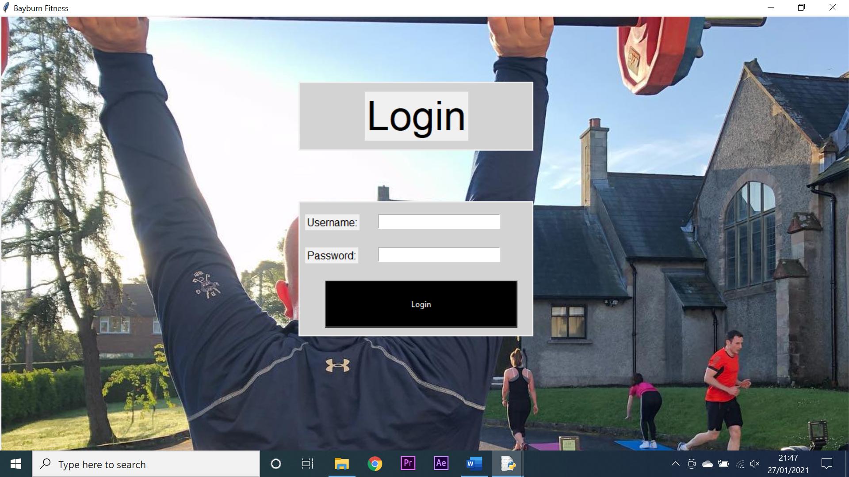

4 - successful